Ryders Hayes School

A Primary Learning Academy



Behaviour for Learning Policy
(including Exclusion)

Ryders Hayes School
Gilpin Crescent
Pelsall
Walsall
WS3 4HX
01922 683008 Policy Author: L. Deeley
info@ryders-hayes.co.uk Date: October 2025

Ryders Hayes School

BEHAVIOUR FOR LEARNING POLICY

Mission: At Ryders Hayes School, children and staff will strive to:

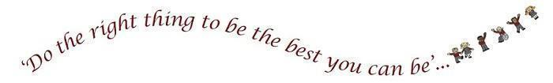

Vision: To nurture and facilitate the growth of our pupils and their learning; equipping them with the skills and attributes to embrace the challenges of a rapidly changing world. To enjoy success for today and be prepared for tomorrow, by instilling the values of:
Character: qualities of the individual essential for being personally effective in a complex world including: grit, tenacity, perseverance, resilience, independence, reliability and honesty.
Citizenship: upholding British Values, thinking like global citizens, considering global issues based on deep understanding of diverse values with genuine interest in engaging with others to solve complex problems that impact human and environmental sustainability
Collaboration: the capacity to work interdependently and synergistically in teams with strong interpersonal and team-related skills including effective management of team dynamics, making substantive decisions together, and learning from and contributing to the learning of others.
Communication: entailing mastery of three fluencies: digital, writing and speaking tailored for a range of audiences, through early, high-quality back and forth interaction.
Creativity: having an ‘entrepreneurial eye’ for economic and social opportunities, asking the right questions to generate novel ideas and explore possibilities, demonstrating leadership to pursue those ideas into practice.
Critical Thinking: critically evaluating information and arguments, reflecting upon them, seeing patterns and connections, constructing meaningful knowledge and applying it in the real world.
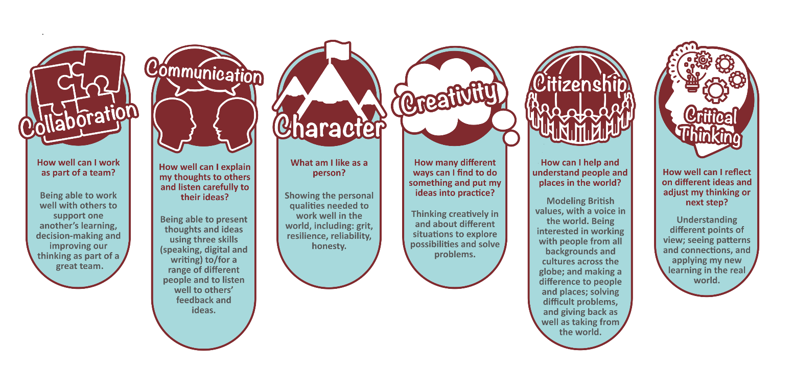

SAFEGUARDING AND PROMOTING THE WELFARE OF CHILDREN
DfE guidance explains that academies should publish their behaviour policy and anti-bullying strategy online
This policy complies with our funding agreement and articles of association.
Keeping Children Safe was issued to schools detailing statutory guidance placing a duty on schools to promote the welfare of children. Safeguarding is a term which is broader than ‘child protection’ and relates to the action taken to promote the welfare of children and protect them from harm. Safeguarding is everyone’s responsibility. Safeguarding is defined in Working Together to Safeguard Children as:
- protecting children from maltreatment
- preventing impairment of children’s health and development
- ensuring that children grow up in circumstances consistent with the provision of safe and effective care and
- taking action to enable all children to have the best outcomes
Safeguarding children is consequently more than contributing to the protection of individual children and the school is committed to the development of policy and practice that supports children and their families to be safe, be healthy, enjoy and achieve, contribute positively and achieve economic wellbeing

Ryders Hayes School strives to promote the welfare of our pupils by:

- Creating and maintaining a safe learning environment through the demonstration of acceptable behaviours
- Identifying child welfare concerns and taking appropriate action.
- Using the curriculum to enable our children to develop keep safe strategies
- Operating safe recruitment and selection procedures to prevent unsuitable people working with our children.

The school has a suite of policies designed to meet these needs and are available on request or via the school website.
This policy applies mostly to point 1 above and reflects current legislation, accepted best practice and complies with the government guidance: Keeping children Safe in Education (2025); and Working Together to Safeguard Children (2023)

Good behaviour in schools is central to a good education. Well-managed schools create cultures where pupils and staff flourish in safety and dignity. Behaviour in Schools - Advice for headteachers and school staff Feb 2024

Ryders Hayes is a Gold Rights Respecting School and as such strongly believes in and promotes the United Nations Convention on the Rights of the Child. All our policies exemplify these rights and our practice aims to ensure that the following rights are adhered to.
Article 3: The best interests of the child must be a top priority in all things that affect children.
Article 12: Every child has the right to have a say in all matters affecting them, and to have their views taken seriously.
Article 13: Every child must be free to say what they think and seek and receive all kinds of information, as long as it is within the law.
Article 14: Every child has the right to think and believe what they want and to practise their religion, as long as they are not stopping other people from enjoying their rights. Governments must respect the rights of parents to give their children information about this right.
Article 19: Governments must do all they can to ensure that children are protected from all forms of violence, abuse, neglect and bad treatment by their parents or anyone else who looks after them.
Article 28: Every child has the right to an education. Primary education must be free. Secondary education must be available for every child. Discipline in schools must respect children’s dignity. Richer countries must help poorer countries achieve this.
Article 29: Education must develop every child’s personality, talents and abilities to the full. It must encourage the child’s respect for human rights, as well as respect for their parents, their own and other cultures, and their environment.
Article 30: Every child has the right to learn and use the language, customs and religion of their family, regardless of whether these are shared by the majority of the people in the country where they live.
Article 36: Governments must protect children from all other forms of bad treatment.
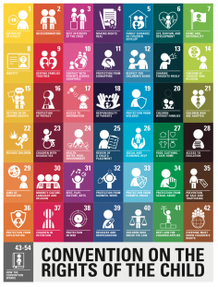

LEGISLATION
This policy is based on advice from the Department for Education (DfE) on:
* Behaviour and Discipline in schools
* Searching, Screening and Confiscation at School
* The Equality Act 2010
* Use of Reasonable Force in Schools
* Supporting Pupils with Medical Conditions at school
* Suspensions and permanent exclusions
It is also based on the Special Educational Needs and Disability (SEND) Code of Practice.

- INTRODUCTION

1.1 The School seeks to promote behaviour based on mutual respect between all members of the School community.

Vision: To nurture and facilitate the growth of our pupils and their learning; equipping them with the skills and attributes to embrace the challenges of a rapidly changing world. To enjoy success for today and be prepared for tomorrow, by instilling the values of: Character, Citizenship, Collaboration, Communication, Creativity and Critical Thinking.

1.2 Ryders Hayes School is committed to providing a stimulating and supportive learning environment based on mutual respect and trust. The school strives to offer equality of opportunity to all of its pupils and recognises the vital role that the educational establishment plays in promoting and furthering social inclusion. As a school we follow the Statutory Guidance ‘Behaviour and Discipline In School’ – A Guide For Head Teachers And School Staff (February 2024) DfE.

1.3 A lot of the support that is needed within the School is for pupils with emotional/behavioural difficulties - some of whom may or may not be statemented. Class teachers, SEND staff and the Wellbeing & Safeguarding Lead offer individual support to pupils who experience emotional/behavioural difficulties and to their teachers - sometimes within the classroom. Children with specific behavioural difficulties, who appear on the School SEND Register, will have an Individual Education Plan to reflect their behavioural difficulties.

1.4 The School's ethos supports the premise that the establishment of a good teacher/pupil relationship is central to working effectively with all pupils- especially those who experience emotional/behavioural difficulties. Teaching which exhibits adaptations, mutual respect and effective classroom management is conducive to building and maintaining good relationships between staff and pupils - however it is inevitable that in certain cases the relationship will break down or never be forged. Emotional and behavioural difficulties take many forms, i.e.

- a pupil may become withdrawn and unable to make friends;
- a pupil may be unable to concentrate on class work or home-learning;
- a pupil may become disruptive and/or aggressive in class.

1.5 In such cases the causes of the emotional/behavioural difficulties should be determined (see later section on 'Health' related causes) and strategies may well be needed to build or rebuild the teacher/pupil relationship. Counselling (non-directive) may be offered to encourage the pupil to express issues of concern and feelings and to determine appropriate actions to deal with the situation. The School believes in the importance of 'negotiating'. This encourages mutual respect and fosters self-responsibility in the pupil. In certain cases tangible rewards may be offered in return for improved behaviour and effort. In cases where trust is minimal this may be formalised into a contract. The use of Behaviourist Psychological Approaches often leads to short term improvements, which in turn improve the teacher-pupil relationship and greater self-motivation.

1.6 Close liaison with all concerned individuals and agencies, e.g. parents, teachers, E.W.S, Schools Psychological Service, Children’s Services, etc. is essential for effective modification of the pupil's behaviour.

RATIONALE

2.1 An effective policy to promote ‘social inclusion’ within the school requires an awareness and understanding of the varied and complex issues surrounding ‘social exclusion’. Social exclusion may result from association or lack of association with groups and places in society, examples of which include: families and friends; neighbours and the neighbourhood; gender; culture; religion; language; accent; class; appearance; lifestyle and ability/disability. In addition, educational attainment, economic status and the degree of stratification between groups may also result in social exclusion.

2.2 In the school environment these factors can contribute to a pupil: feeling alienated/ isolated; feeling that they have a lack of identity; low self-confidence and low self-esteem. With the combined efforts of teaching staff, support staff, parents/guardians and the pupils themselves we aim to intervene as early as possible to help prevent problems from worsening and ensure that all pupils have the chance of a broad, balanced and rewarding education. Where support and advice is sought from other services/outside agencies we will work cooperatively to ensure the best possible outcome for the pupil.

- GENERAL MANAGEMENT

3.1 At Ryders Hayes;
- All teachers have the statutory authority to discipline pupils for misbehaviour which occurs in school, and in some circumstances, outside of school
- The ‘power’ to discipline also applies to any ‘paid’ member of school staff (eg. Members of the Teaching Assistant Team, Site, Administrative or indeed Visiting Specialists/Teachers)
- The Trust Board is responsible for monitoring this behaviour policy’s effectiveness and holding the Head Teacher to account for its implementation.
- The Head Teacher is responsible for reviewing and approving this Behaviour and Learning Policy.
- The Head Teacher will ensure that the school environment encourages positive behaviour and that staff deal effectively with poor behaviour, and will monitor how staff implement this policy to ensure rewards and sanctions are applied consistently.
3.2 Staff
- Staff are responsible for:
* Implementing the Behaviour and Learning Policy consistently
* Modelling positive behaviour
* Providing a personalised approach to the specific behavioural needs of particular pupils
* Recording behaviour incidents

The Senior Leadership Group will support staff in responding to behaviour incidents, through the shared leadership structure.

3.3 Parents
Parents are expected to:
* Support their child in adhering to the pupil code of conduct
* Inform the school of any changes in circumstances that may affect their child’s behaviour
* Discuss any behavioural concerns with the class teacher promptly

3.4 The School employs the following general strategies to support positive behaviour for learning and pupils encouraged to develop levels of independence:
- All pupils have a right to work in a calm, supportive and purposeful atmosphere.
- All pupils have the right to come to school without the fear of being bullied - see 'Anti-bullying' policy.
- Each classroom displays the values and discusses and refers to them on a regular basis when setting daily and long term standards for classroom behaviour. These values prepare pupils for their eventual position in a place of work where procedures have to be followed.
- The School Council with pupil representatives and Pupil Leadership Group (PLG) helps to give the pupils a sense of involvement and citizenship.
- House Captains support the whole school responsibilities system e.g. setting up the hall for collective worship etc also helps to give the pupils a sense of involvement and citizenship.
- Lunchtime Play Leaders organise activity sessions at lunchtimes for Key Stage 1 and 2 pupils. The Wellbeing & Safeguarding Leader, working alongside the Play Leaders creates play opportunities with sports equipment to encourage healthy activity at lunchtimes. Pupils are chosen if they are at risk from disaffection or have problems in school with relationships with other children at that time. These pupils are re-integrated into the playground when they feel comfortable with doing so.
- Class lists and details of pupils with special educational needs (located in class REDFiles) are available for cover/supply teachers to quickly identify and resolve problem areas.
- Agendas for Team Meetings have a regular slot for staff to share problems that they have with specific pupils and information about the pupils and strategies for dealing with the specific problem/individual. This information is fed into Senior Leadership Group meetings and actions are sanctioned to support such pupils.
- All pupils have the right to ask to see the Wellbeing & Safeguarding Lead during any time of the school day. The School adopts this policy in order to remove any barriers to learning at the earliest possible opportunity, but also to support specific behaviour for those children receiving SEND support. However, the timing of this does remain at the discretion of the class teacher.
- Learning Characteristics are part of the whole school ethos and pupils’ are recognised in KS1 & KS2 Praise Assembly for demonstrating resilience, reciprocity, resourcefulness and reflectiveness. At the end of the year, teachers from every year group selects 4 pupils who have demonstrated the characteristics of the Learning Characters to receive a trophy.
- Weekly Mystery Star is selected by the class teacher, this is a child from each year group that
demonstrates one of the 6Cs (values). The Mystery Stars are shared with parents weekly through the school communications channel - Arbor.
- Fortnightly Role Model Award is given in each class with a focus on the 6Cs.
- Trackit Light certificates are awarded for achieving 100, 200, 300, 400, 500,600 and 700 Trackit points.
- The learning environment outside the classroom displays the school values e.g. Hall, Classroom doors, TV screens, Staffroom, etc…
- The school values are used in all whole school assemblies.

- HEALTH RELATED CAUSES OF EMOTIONAL/BEHAVIOURAL DIFFICULTIES

4.1 Many instances of emotional/behavioural difficulties are caused by undiagnosed medical/psychological problems such as speech and language difficulties, hearing loss, visual impairment, depression, anorexia, or bulimia. A known medical condition, such as epilepsy or asthma, even when effectively managed by medication can cause emotional/behavioural difficulties. Indeed the treatment itself can sometimes cause side effects that may lead to emotional/behavioural difficulties. This is often severe in the case of treatment for children with terminal illnesses when treatment inevitably leads to prolonged periods away from mainstream school. In such instances there must be close co-operation between the School, parents and the Local Health Authority if potential problems are to be minimised. In addition, conditions such as ADHD may also give rise to behavioural difficulties. In all such cases, the School Inclusion Leader, in consultation with the Head Teacher, would lead a request for a referral and the involvement of the LA / External Agencies (e.g.Educational Psychologist) in order to assess the pupil as soon as possible.

4.2 The School recognises the importance of Professional Learning and Development (PLD) in this area. Some PLD relating to emotional/behavioural difficulties has taken place, including positive handling of such pupils, and trained staff are willing to facilitate/provide further PLD if required. Additional support is sourced from Beacon Behaviour Support Services.

STANDARDS OF BEHAVIOUR

5.1 In seeking to define acceptable standards of behaviour it is acknowledged that these are goals to be worked towards rather than expectations, which are either fulfilled or not. Thus the School has a central role in the children's social and moral development just as it does in their academic development. Just as we measure academic achievement in terms of progress and development over time towards academic goals, so we measure standards of behaviour in terms of the children's developing ability to conform to our school values.

5.2 The children bring to school a wide variety of behaviour patterns based on differences in home values, attitudes and parenting skills. At school we must work towards standards of behaviour based on the basic principles of: Collaboration, Communication, Creativity, Citizenship, Character and Critical Thinking.
It follows that acceptable standards of behaviour are those, which reflect these principles with ‘Doing the right thing, to be the best you can be’ and ‘Everyday is a learning day’ at the centre of these values. Pupils are expected to:
* Behave in an orderly and self-controlled way both in and out of the school.
* Show respect to all members of staff; visitors; and each other
* In class, make it possible for all pupils to learn
* Move quietly around the school
* Treat the school buildings and school property with respect
* Wear the correct uniform at all times
* Accept sanctions when given
* Refrain from behaving in a way that brings the school into disrepute, including when outside school

SCHOOL ETHOS

6.1 The adults encountered by the children at school have an important responsibility to model high standards of behaviour, both in their dealings with the children and with each other, as their example has an important influence on the children.

6.2 As adults we should aim to:
- Create a positive climate with realistic expectations;
- Emphasise the importance of being valued as an individual within the group;
- Promote, through example, honesty and courtesy;
- Provide a caring and effective learning environment;
- Encourage relationships based on kindness, respect and understanding of the needs of others;
- Ensure fair treatment for all regardless of age, gender, race, ability and disability;
- Show appreciation of the efforts and contribution of all;
- Explain why a behaviour is not acceptable.

SCHOOL COUNCIL and PUPIL LEADERSHIP GROUP (PLG)

7.1 The School Council and PLG exists to encourage greater participation for all in bringing together a sense of belonging. Teachers, the Wellbeing & Safeguarding Lead and pupils are represented in regular half termly meetings. Pupil Councillors feed information from meetings back into class, where pupils can air their views, which in turn are taken to general meetings by their representative.

7.2 The Pupil Leadership Group is a body formed from the House Captains and Vice House Captains. This team works closely with their given role staff member (e.g. Head Learner with Head Teacher). The roles allow the PLG to be a voice for all pupils across school and have an opinion in decision making with the SLT. They have responsibilities across the school, e.g. rewarding good behaviour during assemblies (giving trackits); support the organisation and present in assemblies; lead the school prayer every week with to the whole school; interview candidates applying for a position at Ryders Hayes and show visitors/ prospective new families around the school. The PLG meet weekly and discuss their agreed agenda, which is then fed back into the Senior Leadership Group Meeting.

THE CURRICULUM AND LEARNING
8.1 We believe that an appropriately structured curriculum and effective learning contribute to good behaviour. Through planning for the needs of individual pupils; the active involvement of pupils in their own learning, and structured feedback, pupils avoid the alienation and disaffection which can lie at the root of poor behaviour.

8.2 It follows that lessons should have clear objectives, understood by the children, interactive, stimulating and a rich, adapted curriculum content to meet the needs of children of different abilities. Marking and record keeping can be used both as a supportive activity, providing feedback to the children on their progress and achievements, and as a signal that the children's efforts are valued and that progress matters.

CLASSROOM MANAGEMENT

9.1 Classroom management and teaching methods have an important influence on children's behaviour. The classroom environment gives clear messages to the children about the extent to which they and their efforts are valued. Relationships between teacher and children, strategies for encouraging good behaviour, arrangements of furniture, access to resources and classroom displays all have a bearing on the way children behave.

9.2 Classrooms should be organised to develop independence and personal initiative. Furniture should be arranged to provide an environment conducive to on-task behaviour. Materials and resources should be arranged to aid accessibility and reduce uncertainty and disruption. Displays should help develop self-esteem through demonstrating the value of every individual's contribution, and overall the classroom should provide a welcoming environment.

9.3 Teaching methods should encourage enthusiasm and active participation for all. The School has embedded the principles of Teach Like A Champion (TLAC), research driven by Doug Lemov centered around self-regulation andf meta-cognition. Lessons should aim to develop the skills, knowledge and understanding, which will enable the children to work and play in cooperation with others. Praise should be used to encourage good behaviour as well as good work. The use of ‘Golden-Time, green Trackit’s additional breaktime’ e.t.c. are incentives where children can earn or lose the privilege to participate in some or all of their chosen activity.

9.4 Teaching and support staff are responsible for setting the tone and context for positive behaviour within the classroom.
They will:
* Create and maintain a stimulating environment that encourages pupils to be engaged
* Have shared the pupil code of conduct or their own classroom rules
* Develop a positive relationship with pupils, which may include:

o Greeting pupils in the morning/at the start of lessons
o Establishing clear routines
o Communicating expectations of behaviour – non-verbal as well as than verbally
o Highlighting and promoting good behaviour
o Concluding the day positively and starting the next day afresh
o Having a plan for dealing with low-level disruption
o Using positive reinforcement

- BEHAVIOUR TRACKING – Trackit Lights

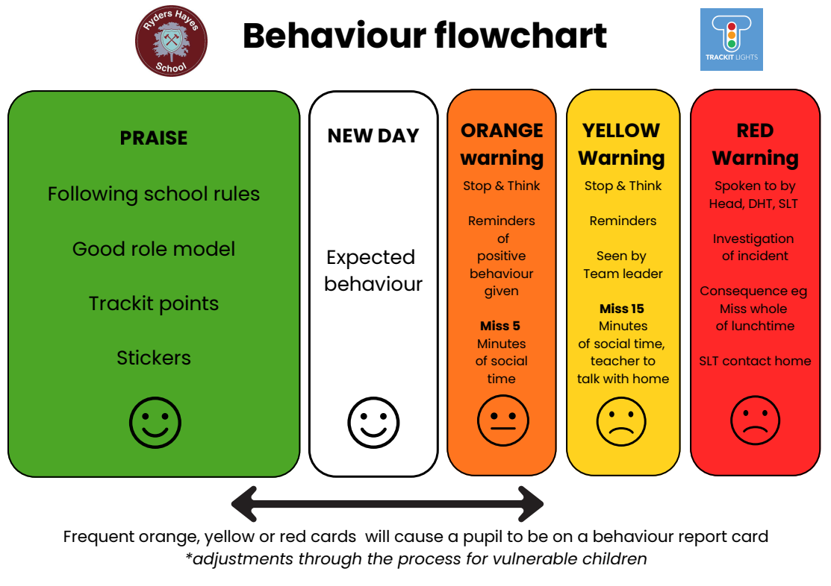
Pupils at Ryders Hayes are expected to “do the right thing, to be the best they can be”
and behave appropriately at all times.

As a school, we incorporate Trackit Lights as an innovative and engaging tool designed to illuminate your child's primary school experience. Trackit Lights has been crafted with your child's growth, development, and academic success in mind. The system provides real-time insights into your child's classroom behaviour, allowing you to stay connected with their progress and celebrate their achievements.

Key Features:
Positive Reinforcement: Our system focuses on promoting positive behaviour by acknowledging and rewarding your child's achievements. Through a colour-coded system, children earn "light points" for demonstrating good behaviour, fostering a sense of accomplishment and motivation.

Encouraging Accountability: By instilling a sense of accountability in your child, Trackit Lights empowers them to take ownership of their behaviour. The system helps children understand the consequences of their actions, promoting self-awareness and personal responsibility.

Holistic Development: Beyond academics, Trackit Lights recognizes and encourages various aspects of your child's development, including social skills, collaboration, and positive attitude, fostering a well-rounded educational experience.

We believe that by incorporating Trackit Lights into our primary school environment creates a more collaborative, positive, and nurturing space for your child to thrive academically and personally. If your child receives a certain amount of Trackit points, they will receive a certificate based on that amount of points, this will be given to them in their year group internal assembly as a reward.

- THE CLASS TEACHER

11.1 The class teacher has prime responsibility for pastoral care. This includes:

- Giving rewards and sanctions.
- Watching out for children who are behaving out of character.
- Looking for signs of distress and upset.
- Through talking and listening to children - suspected occurrences of non-accidental injury or child abuse can be picked up and reported to the Head Teacher (DSL) and or the Deputy DSL Team for further investigation.

REWARDS

12.1 Rewards are a very powerful tool for teachers to use. Our emphasis is on rewards to reinforce good behaviour, rather than on failures. We believe that rewards have a motivational role, helping children to see that good behaviour is valued. The commonest reward is praise, informal and formal, public and private, to individuals and groups. It is earned by the maintenance of good standards as well as by particularly noteworthy achievements. This is as true for adults as for children. Rates of praise for behaviour should be as high as for work. Basically there are four broad categories of reward in order of power:
- Extrinsic rewards, e.g. Golden time, helping the teacher, time on a desired task.
- Tokens (less powerful forms of extrinsic rewards). E.g. Trackit points, Positive Postcards
- Rewards, which occur naturally in the classroom environment e.g. praise, getting work right.
- Intrinsic rewards i.e. the reward for doing something for its own sake or because it is the right thing to do.

Never take a reward away from a child, unless this has been specifically stated.

12.2 REWARDS PROCEDURE

The value of praise by staff must never be underestimated. This can be a verbal or written comment by the teacher to the child. The general practice of classroom management involves many rewards being given to children on a daily basis. These include:
- Verbal praise, written remarks about good work, ‘LC stamps’, and sending children to a nearest teacher or the TeamLeader; Assistant Head Teacher; Deputy Head Teacher/ Head Teacher for praise.
- Displaying pupils' work is a tangible reward available to the teachers. Staff try to ensure that all pupils' work is displayed if it deserves praise and in doing so the pupil will experience pleasure and self-satisfaction – this is done via corridor and shared area boards, but more frequently on the ‘Working Walls’ in the classroom.
- Termly Learning Passports, which are also seen as a vehicle for constructive criticism and praise.
- Positive Postcards: These are organised by the class teacher. They are a positive correspondence home, which are sent home via the child to parents and carers about the progress of their child in a particular area of school life.
- Bi-Weekly Praise award assemblies: Children may receive Praise award certificates from their class teacher in the weekly assembly for demonstrating school 4 learning characters and/or 6Cs through being awarded the following awards : Role model, Certificate of achievement, Star writer or Star reader. Families will be invited to this special assembly to recognise these achievements.
- Character Awards : These are given at the end of each academic year. Characteristics of Learning Awards are given in each year group. Teachers in each year group select four pupils who have demonstrated a particular characteristic for learning consistently throughout the year.
- Trackit Points : Additionally, children are also awarded points for their good behaviour/ good work. The points earned will be rewarded with the presentation of certificates, and prizes as the children’s point total grows. Bronze (100), Silver (200), Gold (300), Diamond (400) and Platinum (600) certificates are awarded for

Trackit Point Achievement Certificates

Trackit light certificates overview
100 Bronze
200 Silver
300 Gold
400 Platinum
500 Emerald
600 Ruby
700 Opal
800 Sapphire
900 Diamond
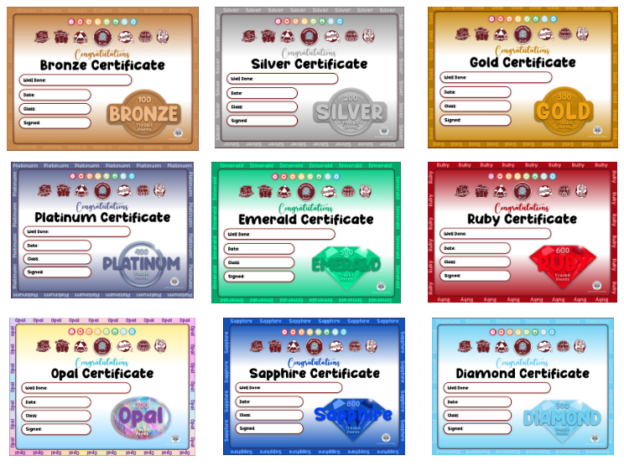

SANCTIONS

13.1 Although rewards are central to the encouragement of good behaviour, realistically there is a need for sanctions to register the disapproval of unacceptable behaviour and to protect the security and stability of the school community. In an environment where respect is central, loss of respect, or disapproval, is a powerful punishment. The use of punishment should be characterised by certain features:

- It must be clear why the sanction is being applied.
- It must be made clear what changes in behaviour are required to avoid future punishment.
- There should be a clear distinction between minor and major offences.
- It should be the behaviour rather than the person that is punished.

Ryders Hayes Behaviour Hierarchy
 | Behaviour | Strategies | Responsibility and Actions
Level 1  Orange | - Poor Behaviour:  - Shouting out  - Disrupting others  - Answering back  - Challenges boundaries appears to lack respect  - Immature/erratic behaviour  - Incompletion of work in class keep child in to complete or send work home | - Establish and maintain class rules  - Reward efforts  - Give respect—Talk to the child quietly without an audience  - Model behaviour that is desired  - Praise children who are doing it right | Class Teacher -  - Monitoring behaviour of class – uses assertive discipline  - Logs behaviour  - Challenge poor behaviour – uses a variety of strategies  Team Leader -  - Check in with class teachers to highlight any persistent orange cards and talk to child - teacher professional judgement of informing parents
Level 2  Yellow | - Persistent poor behaviour  - Disruption in class  - Insolence to class teacher  - Erratic behaviour | - Speak to perpetrator  - Investigate the incident further  - Apply sanctions - miss 15 minutes social time  - Finish work not completed | Team Leader -  - Persistent poor behaviour  - Supports class teachers  - Applies sanctions as appropriate.  - Reports to SLG where appropriate  - Teacher professional judgement to inform parents
Level 3  Red | - Physical aggression, swearing, racism, stealing, bullying, damage or improper use of school equipment, threatening behaviour, not following school rules, inc. non-compliance | - 1:1 contact with the child’s parent  - Set up targets  - Target support  - Team Leader to Liaise with teacher | SLG- Decides upon suitable sanctions.  - Informs/ liaises with parents where necessary  - Liaises with SLT (if needed)
Level 3  Red | Any behavioural problem that is reported by Teachers/SLG  (Medium level) Physical aggression, swearing, racism, homophonic behaviour, stealing, bullying, child on child abuse, damage or improper use of school equipment, threatening behaviour, not following school rules, inc. non-compliance |  | SLT -  - Decides upon suitable sanctions.  - Informs/ liaises with parents where necessary  - Consider if report card is needed
Level 4  Red | Any behavioural problem that is reported by SLT  (High level) Persistent or Serious  Physical aggression, swearing, racism, homophonic behaviour, stealing, bullying, child on child abuse, damage, or improper use of school equipment, threatening behaviour, not following school rules, inc non-compliance | - Apply sanctions  - Set up liaison with families  - Seclusion as appropriate  - Missing of social time - inline with Behaviour policy and flow chart  - Place child on report (after liaison with HT/DHT)  - Reintegration plan outlined to support child moving back into class | Headteacher /DHT -  - Informs families formally  - Suspension/Seclusion for a period of time where necessary/ sets up a modified timetable.  - Informs Trustees / LA where necessary

13.2 Over reference to the Head Teacher or senior leaders for punitive measures to be taken against pupils (rather than support for the teacher) is discouraged and can lead to these key people being forced to occupy a purely punitive role:

(i) It encourages some classroom teachers to abdicate their proper professional responsibility for maintaining order and discipline in the classroom;
(ii) Punishment is delayed and therefore loses some of its effectiveness;
(iii) Senior Leaders cannot carry out their proper function of investigating in depth the reasons why some pupils are unresponsive to the usual methods of reassurance, encouragement, control and punishment.

- ACTION TO BE TAKEN

14.1 In many cases of poor behaviour there are offenders and victims. In such cases we talk to the suspected victim, the suspected offender and any witnesses (if appropriate). If any poor behaviour is confirmed, the following action will be taken:-

14.2 Help, support and counselling will be given as is appropriate to both the victims and the offenders:

We support the victims in the following ways:
- By offering them an immediate opportunity to talk about the experience with their class teacher, or another teacher if they choose;
- Informing the victims' parents/guardians;
- By offering continuing support when they feel they need it; (E.g. Wellbeing & Safeguarding Leader)
- Arrange for them to be escorted to and from the School premises; (if necessary)
- By taking one or more of the sanctions described below to prevent more bad behaviour by the offenders.
- By offering Restorative Justice sessions to both the victim and offender

14.3 We also discipline, yet try to help the offenders in the following ways:
- By talking about what happened to discover why they offended. Sometimes this can be best conducted in private or public (within the class or an assembly) or possibly with the victim present - great care, experience and knowledge of the individuals is necessary for an appropriate choice to be made to avoid damage to relationships and pupils' self-esteem. The most powerful sanction is the disapproval of individuals who an offender respects, e.g. his/her peers, a parent or particular teacher. Teachers should also have opportunities to learn from what has happened. The Senior Leadership Team should make every effort to create a climate in which any sanctions will:
    - have the greatest effect;
    - preclude any re-offence.
- By continuing to work with the offenders in order to get rid of antisocial attitudes as far as possible (this may involve the assistance of outside agencies);
- By taking one or more of the School sanctions described below to prevent more poor behaviour.

15. SANCTIONS PROCEDURES

15.1 Children may be asked to repeat/finish work at break times by staying in. They must not be left unsupervised (The supervision is the responsibility of the class teacher)
Poor behaviour should initially be dealt with by the class teacher . Class teachers should ensure that where children persist in poor behaviour and receive a ‘red card’ during a school day, they are reported to Team Leaders initially, who will chastise them accordingly. The school may use one or more of the following sanctions in response to unacceptable behaviour: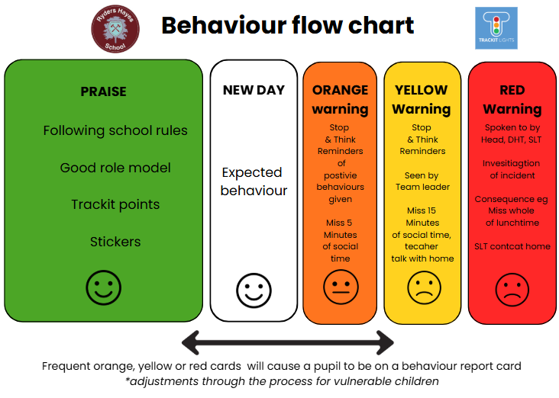
* A verbal reprimand
* Staying in during morning break or part of the lunchtime break
* Sending the pupil out of the class to work in another class
* Expecting work to be completed at home, or at break or lunchtime
* Referring the pupil to a senior leader
* Letters or phone calls home to parents
* Agreeing a behaviour contract
* Putting a pupil ‘on report’
However, in the event of poor behaviour leading to a ‘red-SLT card’ in one lesson, they must be sent directly
to the Assistant Head, Deputy Head Teacher, or in the event of absence directly to the Head of School.
15.2 Children may be asked to take ‘Time Out’ at lunchtimes, following an incident of negative behaviour. Persistent misbehaviour at lunchtime is brought to the attention of the Assistant Head Teacher/ Wellbeing & Safeguarding Leader and may result in the loss of breaktime. Parents will be informed if there is no improvement in behaviour and the child may have to stay in the duration of the lunchtime, or be excluded from the premises at lunchtime for a fixed period. This will be followed, if necessary, by permanent exclusion (ref: Primary Protocol (Fair Access Arrangement)).
15.3 Staying in at Lunchtime – This sanction will be imposed by the HoS/ DHT, and AHTs only – Parental consent is not required and the HoS/ DHT, and AHTs will ensure pupils have a reasonable time to eat, drink and use the toilet. This does not represent an exclusion.
15.4 In all instances suspension at lunchtime has to be recorded and reported according to the LA agreement as part of the exclusion process. All seclusions and suspensions are reported via the HT report to the Local Governing Board and via the CEO Report to Trustees.

15.4 Sanction Procedures are reviewed in accordance with need. If at any time staff members feel that the sanctions laid out in this policy are either inappropriate or ineffective then a review will take place.

16. BEHAVIOUR OUTSIDE SCHOOL

16.1 Guidance states that staff have the statutory powers to discipline pupils misbehaving outside of the school premises. This is the case for behaviours that are witnessed by staff members or those that are reported to the school. This includes any misbehaviour when a child is:
- Taking part in any school-organised or school-related activity or
- Travelling to or from school or
- Wearing the school uniform
- In some way identifiable as a pupil at the school

16.2 In addition misbehaviours at any time, whether or not any of the above apply that:
- Could have repercussions for the orderly running of the school or
- Poses a threat to another pupil or member of the public or
- Could adversely affect the reputation of the school

16.3 In all cases sanctions for behaviours outside school will follow those imposed within school (the closest match will be found), parents will usually be continued. Some of these behaviours will also warrant suspension or permanent exclusion.
16.4 Criminal behaviours will always be reported to the police, regardless of a pupils age, in such cases parents will be informed.
16.5 Sanctions may be applied where a pupil has misbehaved off-site when representing the school, such as on a school trip or to/from school.

17. PROCEDURES FOR DEALING WITH SERIOUS BREACHES OF DISCIPLINE

- Verbal warning by the Head of School/ Deputy Head Teacher or Assistant Head Teacher
- A seclusion
- Reduced timetable
- Involvement of the Police (if appropriate after informing parents)
- A letter to parents informing them of the incident/ problem
- A meeting with parents, and either a warning given about the next stage (which may be suspension) unless there is an improvement in the child’s behaviour, or implementing a Report System
- Lunchtime suspension (See below) if applicable (These must be reported as suspension ref Primary Protocol- Fair Access Arrangements)
- Involvement of external support agencies (if applicable) e.g. Behaviour Educational Support Team
- If the problem is severe or recurring, then suspension /permanent exclusion procedures are implemented by the Head Teacher
- A case conference involving the parents and support agencies to discuss possible exclusion
- Permanent exclusion after consultation with the Trust Board
- Parents have the right to appeal to the Trust Board against any decision to suspend /exclude and to be assured that the suspension/exclusion has been dealt with in accordance with the parameters of the policy. The school and Trust Board is aware that should the procedures not be followed that the decision to suspend/exclude can be overturned by an Independent Appeals Panel.

NB A very serious problem or incident may result in the normal procedure being abandoned and parental involvement straight away.

18. SECLUSION
A decision to use seclusion will be taken if the pupil is demonstrating continuous disruptive behaviour and can only be made by the Senior Leadership Team (SLT).
The SLT will decide how long a pupil should be kept in seclusion and determine what pupils may and may not do during the time. Schools will ensure that pupils are kept in seclusion no longer than is necessary and that their time spent there is used as constructively as possible. Seclusion allows disruptive pupils to be placed in an area away from other pupils for a limited period. This can be within the pupil’s classroom; in another classroom or another room in the school.
Secluded pupils will be supervised throughout the duration.

19. SUSPENSION & EXCLUSIONS

The school follows guidance from the ‘Suspension and Permanent Exclusion from maintained schools, academies and pupil referral units in England, including pupil movement Guidance for maintained schools, academies, and pupil referral units in England’, September 2023 and is based on the following legislation, which outline schools’ powers to exclude pupils:
* Section 52 of the Education Act 2002, as amended by the Education Act 2024
* The School Discipline (Pupil Exclusions and Reviews) (England) Regulations 2024

There are two types of exclusion – Suspension or Permanent

19.1 Suspension (Fixed Term)
A decision to exclude a pupil for a fixed period will only be taken, on a balance of probabilities, only in response to breaches of the school’s behaviour policy, including persistent disruptive behaviour, where these are not serious enough to warrant permanent exclusion and lesser sanctions such as detention are considered inappropriate. Individual fixed period exclusions should be for the shortest time necessary.

19.2 EXAMPLES OF ACTS FOR FIXED TERM EXCLUSIONS (not an exhaustive list – each act will be considered individually in relation to circumstance, severity and/ or frequency)

- Continued disruption to lessons or in school.
- Defiance.
- Verbal abuse to pupils, staff or others.
- Racial abuse to pupils, staff or others.
- Physical abuse to pupils, staff or others.
- Bullying either physical or verbal including Cyber-bullying
- Physical abuse with a weapon.
- Sexually inappropriate behaviour to pupils, staff or others.
- Possession of drugs.
- Theft.
- Vandalism.
- Arson.
- Extortion.
- Possession of a weapon, fireworks or alcohol.
- Threatening behaviour.
- Smoking.
- Setting off fire alarms.
- fraudulent, inappropriate or illegal activity in the virtual world.
- Continued non-compliance with school rules.

19.3 Permanent Exclusion

A decision to exclude a pupil permanently will only be taken:
a) in response to serious or persistent breaches of the school’s behaviour policy; and
b) if allowing the pupil to remain in school would seriously harm the education or welfare of the pupil or others in the school.

21.4 There will, however, be exceptional circumstances where, in the Head Teachers’ judgement, it is appropriate to permanently exclude a child
for a first or ‘one off’ offence. These might include:
a) serious actual or threatened violence against another pupil or a member of staff;
b) sexual abuse or assault;
c) supplying an illegal drug; or
d) carrying an offensive weapon (for advice on what constitutes an offensive weapon, see School Security – Dealing with Troublemakers and DfE School Security November 2018 )

19.5 These instances are not exhaustive, but indicate the severity of such offences and the fact that such behaviour can affect the discipline and well-being of the school community. Each incident will be considered individually in relation to circumstance, severity and frequency.

19.6 A decision to exclude a pupil is not taken lightly and all means necessary will be employed to conclude the ‘facts’ of the incident/incidents. This decision is then based on the principles of whether ‘on the balance of probabilities’ it is more likely than not that a fact is true. It is worth noting than any investigations do not have to give rise to the conclusion that the facts are ‘beyond reasonable doubt’ (as in criminal law)

19.7 Parents do have the right to appeal against either a fixed term or permanent exclusion and are able to lodge a request for an independent review of an exclusions practises details of which can be found in the guidance upon which this policy is based (see appendix)

(see Appendix- Suspension and Permanent Exclusion from maintained schools, academies and pupil referral units in England, including pupil movement Guidance for maintained schools, academies, and pupil referral units in England’, 2024)

All suspensions will be documented and those risk of permanent exclusion will be reported to the Local Authority)

20. DRUG-RELATED EXCLUSIONS (see School Drugs Policy)

20.1 Ryders Hayes School followed the DfE and ACPO drug advice for school and had a Drugs Policy. It clearly states that illegal and other unauthorised drugs have no place within our school and which defines any circumstances where authorised drugs may legitimately be in school.

20.2 In making a decision on whether or not to exclude for a drug-related incident the Head Teacher or teacher in charge will consult the School’s Drug Policy and will consult the designated senior member of staff responsible for managing drug incidents. Where the misuse of authorised drugs is concerned, Head Teacher/ SLT in charge will conduct a careful investigation to judge the nature and seriousness of each incident before deciding what action to take.

20.3 In all cases of exclusion the school will follow the guidance and statutory requirements of ‘Suspension and Permanent Exclusion from maintained schools, academies and pupil referral units in England, including pupil movement Guidance for maintained schools, academies, and pupil referral units in England’, 2024)

21.ON REPORT

The making of a 'report' by negotiation is sometimes appropriate when trust and mutual respect have broken down between the teacher/pupil/parents. The report should be written in such a way that it focuses on specific behavioural problems and offers accrued benefits for achieving the stated goals. The pupil must fully participate in the negotiation - this offers him/her responsibility and can lead to a heightened sense of self-confidence and responsibility for their actions. The utilisation of 'good communication skills' is necessary during the negotiation if all parties are to have ownership of the contract. The report will be monitored according to an agreed timescale with a view to improving negative behaviour.
NB – Pupils can only be put on report by the Head or Deputy Head Teacher

22. PUPILS WITH SEND

The school recognises that nationally the number of children with SEND who have been excluded, is disproportionately higher than those without. Statutory guidance on identifying, assessing and making provision for pupils with SEND, including those with behavioural, social and emotional needs, is given in the Special Educational Needs Code of Practice. Ryders Hayes School follows the guidance set out by this code.

22.1 We ensure that early identification and intervention, accurate assessment and the arrangement of appropriate provision to meet pupils’ SEND happens to minimise risk of exclusions.

22.2 Where anti-social, disruptive or aggressive behaviour are deemed to be part of a child’s Special Educational Need then the process above is followed as part of the schools SEND policy and pupils will have an appropriate Individual Behaviour Plan (IBP) to help manage their behaviour such as a daily or weekly chart to record behaviour. The IBP’s will include appropriate rewards and sanctions.

23. PUPILS WITH DISABILITIES

Ryders Hayes School has a legal duty under the Equality Act 2010 not to discriminate against disabled pupils by excluding them from school because of behaviour related to their disability. This applies to both permanent and fixed period exclusions. A disabled person is defined as someone who has a physical or mental impairment which has a substantial adverse effect on his or her ability to carry out normal day to day activities. The effect must be:
- substantial (that is, more than minor or trivial);
- long term (that is, have lasted or is likely
- to last for at least a year, or for the rest of the life of the person affected);
- and adverse.

23.1 The definition includes people with sensory impairments, and also hidden impairments (for example, mental illness or mental health problems, learning difficulties, dyslexia and conditions such as diabetes or epilepsy).

24. CONFISCATION OF INAPPROPRIATE ITEMS (also refer to DfE Use of Reasonable Force July 2013)
24.1 All staff have the statutory power to confiscate, retain or dispose of a pupil's property as appropriate.
24.2 The Statutory Guidance protects all staff from claims of liability, damage to, or loss of any confiscated items.
24.3 The school may keep records of confiscated items and the grounds for the action, so that they can be justified later if challenged. Teachers will be required to inform SLT, a slip informing the parent of the item that has been confiscated may be sent home, and/ or the parent may be spoken to individually if deemed necessary.
24.4 Pupils have a right to expect that confiscated items, especially those of monetary or emotional value, will be stored safely until they can be returned. For items of obvious value, we will should ensure that the appropriate storage arrangements are made (for example in a lockable unit) If similar items have been confiscated from several pupils, such as mobile phones or personal music-players for example; we will ensure that steps are taken to identify which item belongs to which pupil.
24.5 For some items, school staff should seek specialist advice, for example, suspected illegal drugs, weapons or items which might be used as weapons (e.g. Disposal of Weapons Guidance Circular 328). A close working relationship with the local police, means that they may be involved at this stage.
24.6 The following criteria may be used when determining if it is deemed necessary for staff to confiscate an item from a pupil (not an exhaustive list and each situation will be considered in terms of severity, frequency:
- an item poses a threat to others: for example, a laser pen is being used to distract and possibly harm other pupils or staff
- an item poses a threat to good order for learning: for example, a pupil uses a personal music-player in class.
- an item is against school uniform rules: for example, a pupil refuses to take off a baseball cap on entering a classroom.
- an item poses a health or safety threat: for example, a pupil wearing large ornate rings in PE may present a safety threat to other pupils.
- an item which is counter to the ethos of the school: for example, material which might cause tension between one community and another.
- an item which is illegal for a child to have: for example, racist or pornographic material; protocols for how to deal with such items can be agreed with local police.

24.7 Confiscating items of clothing or jewellery:
Staff should take particular care when deciding whether to confiscate items of clothing or jewellery. In particular, they should have appropriate regard to whether the item in question has religious or cultural significance to the pupil and should avoid physical contact or interference with pupils' clothing of a kind that might give rise to child abuse allegations. In order to minimise such risks, teachers must ensure that if an item of clothing or jewellery is confiscated, that this is done by a staff member of the same gender as the pupil and with another staff member present where possible. Confiscation of any item that would leave the pupil only partly dressed must be avoided.

24.8 The school policy on confiscation of pupil mobile phones and the safety of pupils on their journey home:
‘If a child has a mobile phone for a specific purpose or a parental concern, these phones should be handed in (or confiscated) at the start of the school day but staff should ensure that they return them to the pupil at the end of the school day.’

24.9 How long should items be confiscated for?
In most cases, confiscation is a sufficient sanction, and return of the item at the end of the day is adequate time to reinforce the school rule. This also limits the chance of problems with loss of items while in the care of school staff.
24.10 There may be some instances when the school chooses not to return an item to the pupil:
- Items of no value, such as an inappropriate message scrawled on a piece of paper, may simply be disposed of. However, staff should keep in mind that some items of seemingly no value may have emotional value to the child — staff should establish if this is the case before deciding whether or not to dispose of the confiscated item.
- Items of value which the pupil should not have brought to school, or has misused in some way, might, if the school judges this appropriate and reasonable, be stored safely at the school until a responsible family adult can come to retrieve them. For example, there is no acceptable reason why a pupil should bring a cigarette lighter to school. In such circumstances retention is a reasonable step both to protect property, and to enable discussion about whether the pupil is smoking and how this can be addressed.
- Other items which the pupil should not have had in their possession, particularly of an unlawful or hazardous nature, may be given by the school to an external agency for disposal or further action as necessary. This should always be followed by a letter or phone calls to the parents confirming that this has taken place and the reasons for such action.

25. THE POWER TO SEARCH WITHOUT CONSENT (for prohibited-items)

The law also allows staff to ‘search pupils’ without their consent if it is suspected that they may have the following in their belongings or about their person;

- Knives and weapons
- Alcohol
- Illegal drugs
- Stolen items
- Tobacco and cigarette papers
- Fireworks
- Pornographic images
- Any item that has been OR is likely to be used to commit an offence, cause personal injury or damage property
- Any item banned by the school rules

26. PHYSICAL INTERVENTION

26.1 The legal provisions of the discipline guidance (Use of reasonable force) also provide members of school staff with the power to use reasonable force to prevent pupils committing an offence, injuring themselves or others or damaging property, and to maintain good order and discipline in the classroom.

26.2 The Head Teacher and other authorised staff may also use reasonable for to conduct a search without consent for knives or weapons, alcohol, illegal drugs, stolen items, tobacco and cigarette papers, fireworks, pornographic images or articles that have been or could be used to commit an offence or cause harm

26.3 Staff inc. SLG has received training for Positive Handling. This enables them to de-escalate and remain safe in potentially violent situations.

26.4 If a child violently attacks another child or adult and does not respond to request to calm down, then physical restraint may be necessary, however physical restraint would only be used as a last resort.

26.5 In the event of physical restraint taking place a member of the Senior Leadership Team will be notified and summoned and the procedures outlined in the Physical Restraint Policy followed.

26.6 PHYSICAL RESTRAINT INCIDENT RECORDS

An incident record should be filled in for any incident of negative behaviour resulting in being sent to a member of the Senior Leadership Team (SLT) on Trackit Light System. SLT should then detail the relevant action taken on Trackit Lights - Physical Restraining Form.

Incidents may give rise to disciplinary action, or legal action, or become a matter of public interest (e.g. confrontational issues, absconding etc) and should be LOGGED AT ALL TIMES on TRACKIT LIGHT

27. BULLYING (Ref: Anti-bullying Policy)

Bullying as defined in our Anti-bullying policy, which includes;
- Emotional being unfriendly, excluding, tormenting (e.g. hiding books, threatening gestures)
- Physical pushing, kicking, hitting, punching or any use of violence
- Racist racial taunts, graffiti, gestures
- Sexual unwanted physical contact or sexually abusive comments
- Homophobic because of, or focussing on the issue of sexuality. The language used and associated with homophobic bullying.
- Verbal name-calling, sarcasm, spreading rumours, teasing
- Cyber All areas of internet, such as email & internet chat room misuse
Mobile threats by text messaging & calls
Misuse of associated technology , i.e. camera & video facilities
- Disabilities Bullying which involves children with Special Educational Needs and disabilities.

….is considered to be anti-social behaviour and affects everyone; it is unacceptable and will not be tolerated. The Anti-bullying policy outlines identification, statutory duties and strategies for dealing with this issue.

28. RACISM (Ref: Anti-bullying Policy)

Like bullying this too is considered to be anti-social behaviour and will not be tolerated. All incidents of racism should be reported to a member of the SLT, so that they can be recorded on the appropriate LA Monitoring System and subsequently reported to Trustees at the Termly Meeting.

28.1 At Ryders Hayes we need:-
- To do everything in the school’s power to combat racism of all forms and treat it as a challenge to civilised living.
- To provide for the individual needs of the learners, having regard to their ethnic, religious, linguistic, cultural and historical background.
- To ensure that the learning experience is free from bias in its portrayal of either ethnic minorities or the majority culture.
- To prepare all pupils for life in a multicultural society, building upon the strengths and richness of cultural diversity.
- To promote mutual understanding, tolerance and respect among pupils of all backgrounds.
- To counter racism and combat discriminatory practices.

28.2 STRATEGIES FOR DEALING WITH RACISM (Ref: Anti-bullying Policy)

- Involve parents and others, from other cultural and ethnic backgrounds, in activities at school e.g. class visits, craft groups etc.
- To make it clear that bullying of a racist nature will not be tolerated.
- Children to be exposed to books, art, food etc., from minority cultures.
- Recognise in school - through R.E. and assemblies - the worth of the world’s major religions.
- Cultural events within school and themed days.
- School focus on Racial Literacy.

29. PUPIL NON-COMPLIANCE (UNIFORM)
Teachers can discipline pupils for breaching the school’s rules on appearance or uniform.
The Head Teacher/Head of School/Deputy Head of School, may ask a pupil to be collected to go home briefly to remedy a breach of the school’s rules on appearance or uniform. When making this decision the school will consider the child’s age and vulnerability, the ease and time it will take, and the availability of the child’s parents. This is not an exclusion but an authorised absence. However, if the pupil continues to breach uniform rules in such a way as to be sent home to avoid school, or takes longer than is strictly necessary to effect the change, the pupil’s absence may be counted as an unauthorised absence. In either case the pupil’s parents must be notified and the absence will be recorded. The school may consider excluding a pupil in response to breaches of uniform policy in which case it will be in line with the legal requirements for exclusion. (See Non-Compliance Process in Appendix)

30. COMMUNICATION AND PARENTAL PARTNERSHIP

30.1 We give high priority to clear communication within the school and to a positive partnership with parents, since we believe that these are crucial in promoting and maintaining high standards of behaviour. Where the behaviour of a child is giving cause for concern it is important that all those working with the child are aware of those concerns and of the steps, which are being taken in response. Early warning of concerns should be communicated to the SLT, Deputy Head of School and/ or Head of School so that strategies can be discussed and agreed before more formal steps are required.

31.2 A positive partnership with parents is crucial to building trust and developing a common approach to behaviour expectations and strategies for dealing with problems. Parental participation in school life is encouraged and support for dealing with poor behaviour of any kind is expected. This participation assists the development of positive relationships in which parents are more likely to be responsive if the school requires their support in dealing with difficult issues of unacceptable behaviour. The school will communicate policy and expectations to parents. Where behaviour is causing concern parents will be informed at an early stage, and given an opportunity to discuss the situation. Parental support will be sought in devising a plan of action (Report- See Appendix) within this policy, and further disciplinary action will be discussed with the parents.

31. PARENTAL SUPPORT AND A CODE OF CONDUCT

At Ryders Hayes School we like our children to feel secure and expect them in return to follow a code of conduct based upon considerations towards other members of our school community.

31.1 The discipline of a child is not solely a school responsibility but is a partnership between home and school. At Ryders Hayes we have established an Assertive Discipline Programme which is based on asserting the rights of the child to be educated and the rights of our teachers to teach. We greatly value parental co-operation in asserting these rights and their support is crucial.

31.2 A common approach is crucial and we expect that parents play their part in fostering a positive attitude towards their child’ commitment to the school.

31.3 After consultation with the children, parents and trustees of our school we have established a Code of Conduct that is distributed to parents and children as part of the Home-School Promise (See Appendix), which parents are strongly encouraged to sign.

32. OUTSIDE AGENCIES
All schools have a wealth of experience amongst the staff and by applying this valuable resource appropriately most problems can be resolved without the need for specialist help. However, on certain occasions help may need to be sought from outside agencies.
See Equalities, Equal Opportunities and Anti-bullying policies

33. REVIEW OF POLICY

The Head Teacher/ Head of School is responsible for reporting to the Local Governing Board (LGB) (and the local authority where applicable) on how the policy is being enforced and upheld, via the termly report. The LGB are in turn responsible for monitoring the effectiveness of the policy via the termly report and by in-school monitoring such as learning walks and focus groups with pupils. The policy is reviewed annually, in consultation with the whole school community including staff, pupils, parents, carers and Local Governing Board.

Legislative links

https://www.gov.uk/government/publications/behaviour-in-schools--2

https://www.gov.uk/government/publications/school-exclusion

https://go.walsall.gov.uk/sites/default/files/2022-08/Walsall%20Accessibility%20Strategy%202020-2023.pdf
https://assets.publishing.service.gov.uk/media/62d1643e8fa8f50bfbefa55c/Searching__Screening_and_Confiscation_guidance_July_2022.pdf
https://www.gov.uk/guidance/equality-act-2010-guidance
https://www.gov.uk/government/publications/use-of-reasonable-force-in-schools
https://www.gov.uk/government/publications/supporting-pupils-at-school-with-medical-conditions--3
https://www.gov.uk/government/publications/send-code-of-practice-0-to-25
APPENDIX: School Security – Dealing with Troublemakers – Chapter 6

APPENDIX: Home-School Promise
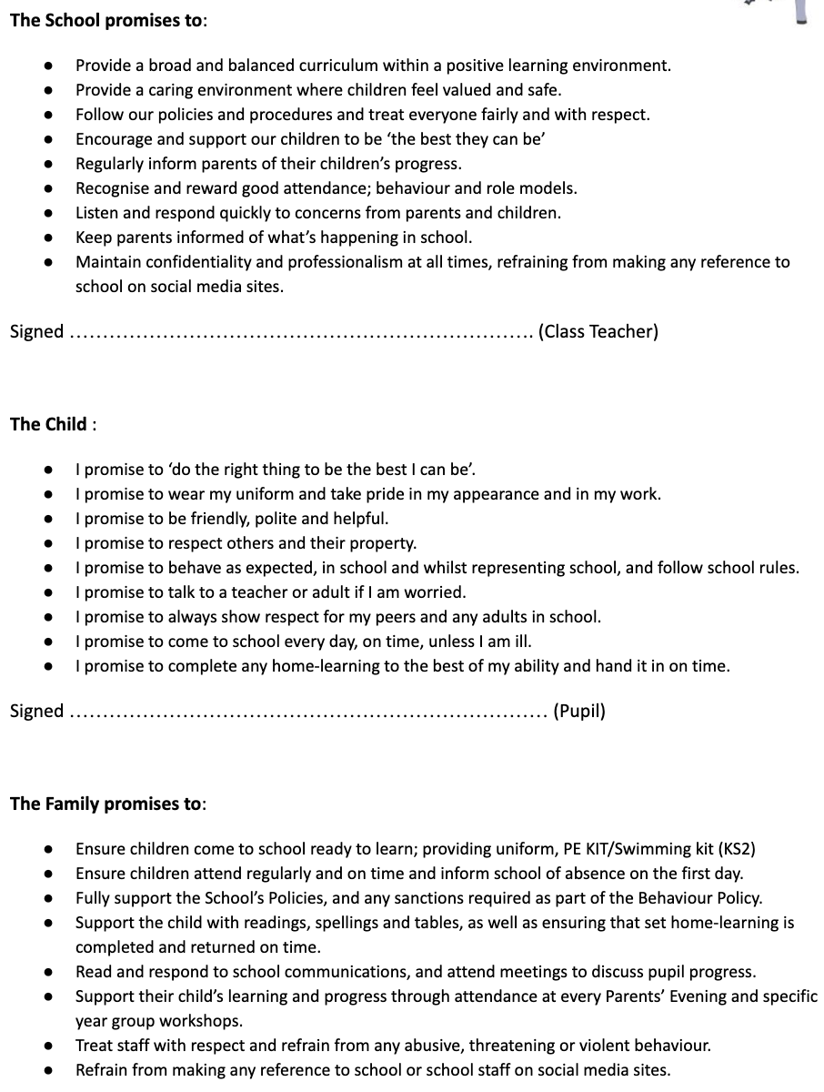

APPENDIX: Weekly Behaviour Report

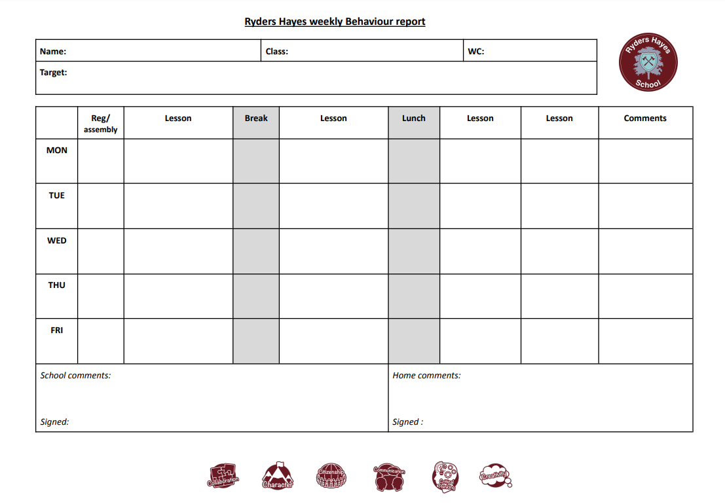

APPENDIX: Daily Behaviour Report

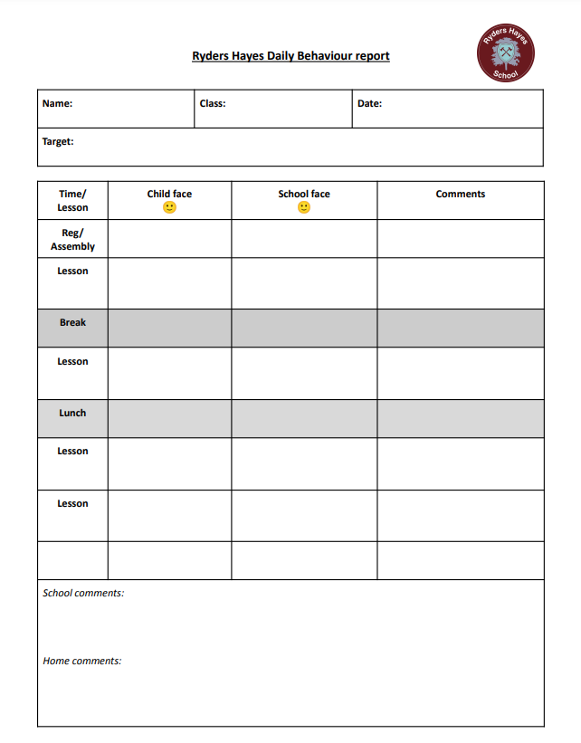

APPENDIX: Non-compliance with School Uniform Policy

If a pupil is not wearing the correct uniform from September 2023 onwards as stipulated in our policy on the website the following steps will be taken:

- A member of staff (which may be the child’s class teacher), will ask the parent whether there are any known reasons why the child is unable to wear/have the specified school uniform item.
- Should there be any legitimate reason for non-compliance, then the parent must notify the Head or Deputy Head Teacher immediately in writing, so that reasonable adjustments can be made (Equalities Act 2010).
- If there is no apparent reason for the non-compliance, a warning letter will be sent, giving the parent five working days from the date of the letter to purchase the required uniform. During this time the child will be required to leave their non-uniform item(s) in the Main Office during the day and may take an indoor mid-morning and lunchtime break if without the item it would not be appropriate to go outside.
- Should the parent persist in not complying with the policy, then we have no alternative but to ask them to collect their child and bring them back with the required item of uniform. This is not an exclusion but an authorised absence. This should take no longer than is strictly necessary.
- If parents continue to breach the uniform rules, or it takes longer than is strictly necessary to effect the change, the pupil’s absence may be counted as an unauthorised absence. The absence will be recorded on the pupil record and normal procedures begun with the Local Authority.
- If the issue persists then action may be taken in line with our Behaviour for Learning Policy and ultimately legal requirements for exclusion.

APPENDIX: Positive Handling Training List

Name | Title | Role
Jaz Paul | Executive Head Teacher | SLT
Lou Deeley | Head of School | SLT
Cheryl Heaton | Asst. Head Teacher | SLT
Victoria Day | Asst. Head Teacher | SLT
Alison Jackaman | Senior Teacher | SLG
Emily D’Sylva | Team Leader | SLG
Claire Raxworthy-Cooper | Team Leader | SLG
Marcos Rylance | Wellbeing and Safeguarding Lead | SLG
Donna Griffiths | Teaching assistant | Support staff
Leanne Griffiths | Teaching assistant | Support staff

