Ryders Hayes School
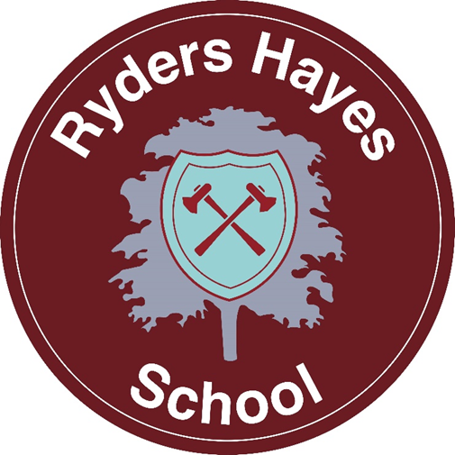
A Primary Learning Academy

Guidance for Art and Design
Ryders Hayes School
Gilpin Crescent
Pelsall
Walsall
01922 683008
postbox@ryders-hayes.co.uk

Mrs Swann
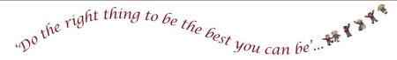

Guidance for Art and Design

1. Introduction

Vision : At Ryders Hayes we aim to inspire every child to think like an artist: experimenting without fear, expressing unique ideas, and discovering the world through creative curiosity.
Principles:
Line – We offer the children the chance to explore marks made and apply them.
Shape – We offer the children the chance to explore geometric and organic two-dimensional areas of enclosed space and apply them.
Form – We offer the children the chance to explore three-dimensional versions of shape that can be viewed from different angles and apply them.
Space – We offer the children the chance to explore illusions of depth and distance and apply them.
Texture – We offer the children the chance to explore the way things feel or look and apply them.
Value – We offer the children the chance to explore the range of light and dark and apply them.
Colour - We offer the children the chance to explore different sensations on the eye from the way something reflects light and apply them.
Aims:
- To develop understanding of, recognise and utilise the Elements of art within their own and others work (line, shape, colour, texture, space and value).
- To develop understanding of, recognise and utilise the Principles of art within their own and others work (pattern, emphasis, variety, unity, balance, movement and proportion). • To develop experience and mastery of a range of art techniques (drawing, painting, collaging, 3D construction, print making and textiles).
- To develop skills and mastery in a range of art materials (for example, charcoal, acrylic paint, clay).
- To develop knowledge about different art movements through the practises and works of a range of artists, craft makers and designers throughout history.
- To explore and develop their own ideas and style through experimentation and adaptation.
- To evaluate their own and others art work through reference to artists, art movements, elements, principles and techniques.

2. Intent
Ryders Hayes Curriculum Model
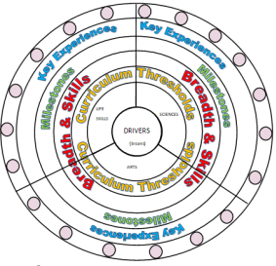
At Ryders Hayes each subject holds threshold concepts; the key disciplinary mastery aspects of each subject. They are chosen to build conceptual understanding within subjects and are repeated many times in a variety of experiences.
The Art and Design threshold concepts are-
• Self-expression through medium, technique and ideas.
• Innovation through using others techniques and adapting them.
• Culture & Past times through using existing places and past and present events as inspiration.
The threshold concepts are divided into three milestones. We expect pupils in year 1 of the milestone to develop a secure understanding of the concepts and a deeper understanding in year 2 of the milestone. Phase one (Yr1, Yr3, Yr5) in a Milestone is the knowledge building phase that provides the fundamental foundations for later application. Learning at this stage must not be rushed and will involve a high degree of repetition so that knowledge enters pupils’ long-term memory. If all the core knowledge is acquired quickly, teachers create extended knowledge.
The curriculum at Ryders Hayes has three drivers chosen specifically to permeate the curriculum to meet the needs of our children and their local context.
The Curriculum Drivers for Ryders Hayes School are to:
• Explore possibilities
• Create independence
• Build resilience

3. Implementation
We have developed and reviewed the national scheme of guidelines for Art and Design as the basis for our curriculum planning. We review our long-term plan on an annual basis.
Supporting our Curriculum Drivers, we have our knowledge categories which provide the key knowledge within subjects and help us to grow our cultural capital; making links where appropriate to our children and their learning.
The Knowledge Categories for Ryders Hayes School are:
• Location
• Settlement
• Culture and pastimes
• Significant events
• Food and farming
• Number
• Self-expression
• Career related
• Beliefs
• Innovation
• Language and oracy
• Peace and war
Within each year group key concepts are taught at stages throughout the school year. These again focus on the need, and importance, of repetition in our curriculum.
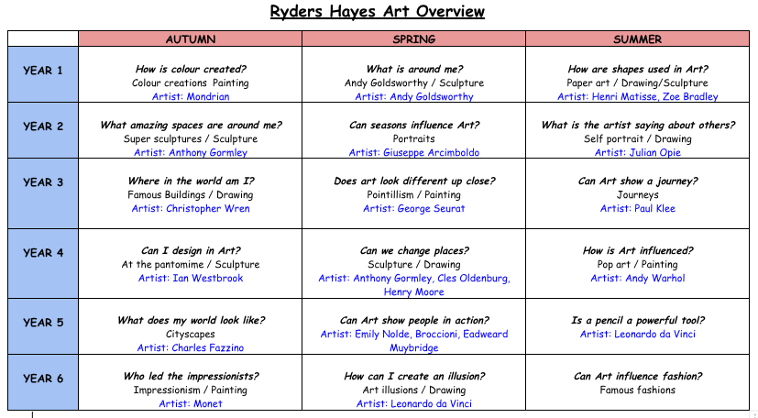
Teaching and Learning in Art and Design will be in line with the school’s Behaviours for Learning Policy, where provision is made for all learning styles.
The Art and Design curriculum at Ryders Hayes School is designed to provide children with learning opportunities that reflect the breadth and balance of contexts outlined in the National Curriculum, as well as well-planned repetition to ensure secure foundation of Art and Design knowledge and skills.
We display and share the characteristics of an Artist, as well as investigating career opportunities, with children at every available opportunity. Art and Design is allocated a board in one of the corridors to celebrate and share children’s art work from across the school.
Key Experiences:
Ryders Hayes Art and Design curriculum is a bespoke model to cater for the needs of the children and key experiences have been carefully selected to ensure that they allow children to explore/create/ build: possibilities, resilience and independence. The Key experiences include:
• Regular galleries to display and share art work to provide purpose.
• Whole school topic based art projects (for example during special occasions such as Earth Day or Mother’s Day).
• Whole school Art focus days throughout the year.
• Art competitions throughout the year (to include both in school and out of school community links). Competitions will be whole school or Key Stage based depending on their suitability.
Resources:
- The subject leader must monitor the Art resources closely according to the planning and end of year expectations, and therefore must order materials as and when needed. • All art material orders must be in accordance with the budget allocated, with the subject leader being given a copy of the order form for their records.
- Termly audits will be carried out by the subject leader to ensure all year groups across the school are appropriately resourced.
- Tools, equipment and materials must be risk assessed for safety before lessons to ensure they have been maintained and that the children know how to handle them correctly and safely before use.
- Art materials and tools should be maintained by being kept clean as well as being stored appropriately in order to ensure continued use.
- When partaking in messy art activities children must protect their school uniform by wearing aprons and rolling up their sleeves. At the end of a messy art activity children must wash their hands.
Health and Safety:
- Health and safety during art lessons is extremely important, particularly when working with tools, equipment and resources. Therefore, children need to be taught beforehand how to;
1) handle and use tools and equipment correctly and safely
2) recognise hazards and risks and how to control them.
- Existing risk assessments are available for all Art mediums and tools. These should be read before the lesson by the teacher and any other adults partaking in the activity. The points within the risk assessment must then be shared with the children in the class.
Inclusion:
- Every child is an artist and therefore has the right to take part in artistic activities. Where needed, lessons will be adapted to take into account the needs of individuals regarding resources, tools, equipment, health and safety, techniques and adult support.
- When allergies or medical conditions prevent a child from using a particular material or tool, differentiated support and adapted planning will take place to ensure their participation.
- Where needed, working groups will be differentiated to allow every child to reach their full potential.
Staff training:
- Skills and mediums CPD will be provided regularly to staff to ensure confidence in the subject.
- Staff will be kept up to date with curriculum changes and Ofsted guidance.
- Staff’s CPD needs will be audited in order to provide training according to their art curriculum needs.
- As and when required according to the art materials ordered, staff will be trained by the subject leader in their storage, maintenance and use.
The role of the Art and Design Leader is to:
- Support colleagues in teaching the subject content and developing their skills in planning, teaching and assessing Art and Design.
- Renew, update and oversee the audit of resources needed to deliver the curriculum.
- Monitor and evaluate the learning and teaching of Art and Design through learning walks and month book trawls.
- Develop assessment and record keeping ensuring progression and continuity.
- Communicate findings, ideas and resources and have an open-door policy for suggestion and questions.
- Design the Medium- Term Plans for teachers to use and annotate for weekly lessons.

4. Impact
The curriculum design and planning will lead to outstanding progress for all pupils, regardless of their starting points, over time. Learning is progressive and builds on prior knowledge and understanding and supports children in producing outcomes of the highest quality. Teaching and learning is adapted to cater for the needs of all pupils; providing support for children with special educational needs and enrichment and challenge for more able children.
Opportunities for assessing the impact will be identified in curriculum overviews for each age group, and these will be based on an assessment of key skills and essential knowledge and understanding within Art and Design.
Methods of assessment will vary as appropriate to the learning. An exemplification portfolio of work from Y1 to Y6 will show examples of Art and Design work; as well as appropriate evidence from EYFS – understanding the world and will be used to support judgments.
In Art and Design the use of technology is also used to record and gain evidence of children’s knowledge and skills. Children will be set small tasks in order to demonstrate the knowledge and skills they have learnt during their learning journey and as part of end of Milestones. These tasks will be completed throughout the year to monitor and evidence progression and attainment. Pupil voice will be used to assess the progress in understanding and applying skills needed to become an Artist.
Monitoring and Evaluation:
The teaching and learning of Art and Design will be monitored through the analysis of medium-term planning, pupil voice interviews, analysis of assessment data, scrutiny of work samples, completion and recording of Art and Design tasks to assess skills and knowledge and learning walks, in line with the School Development Plan.
The Art and Design leader will evaluate progress that has been made and the impact of the curriculum to ensure all pupils have been taught the knowledge and skills they need to deepen their artistic understanding.

