Ryders Hayes School

A Primary Learning Academy

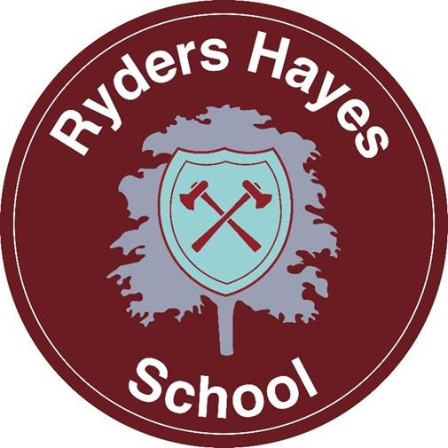

Physical Education Guidance

Ryders Hayes School Gilpin Crescent Pelsall
Walsall
WS3 4HX Todd Moon
01922 683008 PE Leader
postbox@ryders-hayes.co.uk
  - The School seeks to promote behaviour based on mutual respect between all members of the School community. Ryders Hayes aims to:

….nurture and facilitate the growth of our pupils and their learning; equipping them with the skills and attributes to embrace the challenges of a rapidly changing world. To enjoy success for today and be prepared for tomorrow, by instilling the values of: enquiry; adaptability; resilience; morality; effective communication; thoughtfulness; collaboration; respect; international /open mindedness and a growth mind-set.

  - This guidance outlines the learning, teaching, organisation and management of Physical Education at Ryders Hayes School.

  - The implementation of this guidance is the responsibility of all teaching staff. The responsibility for monitoring and review rests with the Physical Education Leader- Todd Moon.

  - The curriculum is designed to build a schema by developing knowledge and vocabulary through a range of topics and deliberate practice.
2. Our Intent
  - Ryders Hayes Curriculum Model
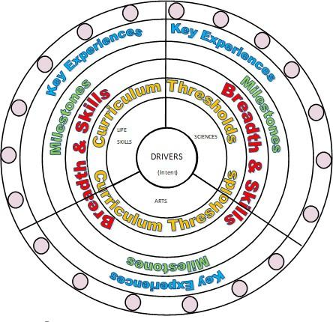
  - At Ryders Hayes each subject holds threshold concepts; the key disciplinary mastery aspects of each subject. They are chosen to build conceptual understanding within subjects and are repeated many times in a variety of experiences.
  - The threshold concepts in Physical Education are: Fundamental Skills
Gymnastics Games Athletics Dance Swimming
Outdoor Adventurous Activities.

  - The threshold concepts are divided into three milestones. We expect pupils in year 1 of the milestone to develop a secure understanding of the concepts and a deeper understanding in year 2 of the milestone. Phase one (Yr1, Yr3, Yr5) in a Milestone is the knowledge building phase that provides the fundamental foundations for later application. Learning at this stage must not be rushed and will involve a high degree of repetition so that knowledge enters pupils’ long-term memory. If all the core knowledge is acquired quickly, teachers create extended knowledge.

  - The curriculum at Ryders Hayes has three drivers chosen specifically to permeate the curriculum to meet the needs of our children and their local context.

  - The Curriculum Drivers for Ryders Hayes School are to: Explore possibilities
Create independence Build resilience
  - Through our teaching of Physical Education, we intend to:
Provide quality-sporting opportunities for all children, catering for interests and differing individual abilities. Develop children’s skills, knowledge and confidence in Physical Education.
Educate and encourage children to lead healthy active lives whilst improving and sustaining health and wellbeing.
Promote positive attitudes and enjoyment, developing fair play and respect. Give children the opportunities to engage in competitive sport.
Develop an ability to plan a range of movement sequences, organise equipment and apparatus and begin to design and apply simple rules.
Develop communication skills, encourage the use of correct terminology and promote the ability to work in a team.

  - Entitlement and Equal Opportunities
We are committed to providing a teaching environment conducive to learning.
All pupils are entitled to access the Physical Education curriculum at a level appropriate to their needs arising from race, gender, ability or disability, religion, social background and culture.

  - Organisation of Physical Education in the Curriculum
Physical Education is part of the Life Skills focus for learning. This enables Physical Education, Me in My World, Careers and Relationships and Sex Education to work together sharing best practice, modelling and support excellence and holding each other to account of our Subject Lead responsibilities.
3. Our Implementation

  - We have developed and reviewed the national scheme of guidelines for PE as the basis for our curriculum planning. We review our long-term plan on an annual basis.
  - Supporting our Curriculum Drivers, we have our knowledge categories, which provide the key knowledge within subjects and help us to grow our cultural capital; making links where appropriate to our children and their learning.

  - The Knowledge Categories for Ryders Hayes School are: Location
Settlement
Culture and pastimes Significant events Food and farming Number
Self-expression Career related Beliefs Innovation
Language and oracy Peace and war

  - Within each year group key concepts are taught at stages throughout the school year. These again focus on the need, and importance, of repetition in our curriculum.
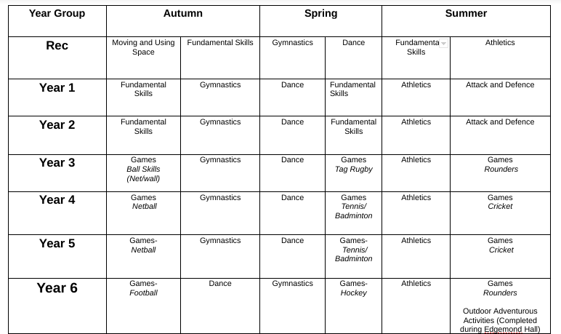

  - Teaching and Learning in Physical Education will be in line with the school’s Behaviours for Learning Policy, where provision is made for all learning styles. The Physical Education curriculum at Ryders Hayes School is designed to provide children with learning opportunities that reflect the breadth and balance of contexts outlined in the National Curriculum, as well as well-planned repetition to ensure secure foundation of PE knowledge and skills.

  - As an integral part of the teaching and learning of Physical Education, children will be given the opportunity to take part in a range of Physical Education activities including competitive sport.

  - We display and share the characteristics of a Sports person (athlete) as well as investigating career opportunities, with children at every available opportunity. Physical Education is allocated a board in one of the corridors to celebrate and share children’s success from across the school.
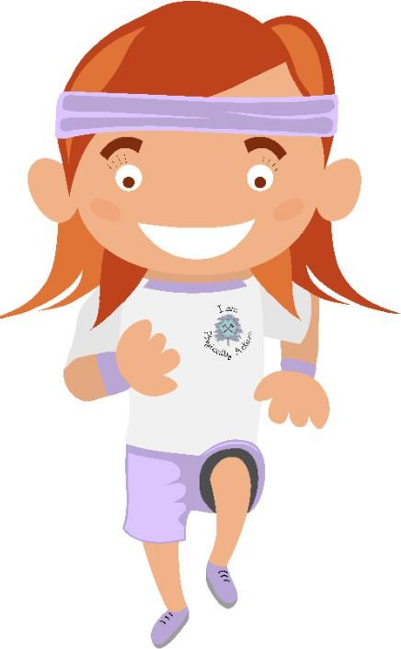

  - Key Experiences:

Ryders Hayes Physical Education curriculum is a bespoke model to cater for the needs of the children and key experiences have been carefully selected to ensure that they allow children to explore/create/ build possibilities, resilience and independence. The Key experiences include:

    - Extra-Curricular clubs – lunchtime and / or after school.
    - Regular whole school inter-house competitions- including Sports Day in the summer term.
    - Whole school Physical Education focus days, linking to yearly sporting events, such as World Cups, Soccer Aid etc.
    - Physical Education intra- competitions throughout the year.
    - Teaching from specialised coaches including Walsall Football Club.
    - Opportunities for children to take part in extra-curricular activities with secondary school specialists such as Streetly Academy, for example boxing and playground leadership opportunities.
  - The role of the Physical Education Leader is to:
Support colleagues in teaching the subject content and developing their skills in planning, teaching and assessing PE.
Renew, update and oversee the audit of resources needed to deliver the curriculum.
Monitor and evaluate the learning and teaching of PE through learning walked and moderation of assessment. Develop assessment and record keeping ensuring progression and continuity.
Communicate findings, ideas and resources and have an open-door policy for suggestion and questions. Design the Medium- Term Plans for teachers to use and annotate for weekly lessons.

  - Resources:
The facilities for the teaching of Physical Education at Ryders Hayes are as follows:
Multi-purpose hall
Carpeted art room available for some activities for younger children and small groups Grassed area-field
Two small playgrounds
Outdoor multi-purpose cage area

Staff should endeavour to make full use of both indoor and outdoor facilities to provide appropriate experiences for pupils within the activity being taught.

Indoor Resources

Storage of apparatus for gymnastics is around the confines of the hall. Small apparatus is stored in a cupboard in the hall.
Staff should ensure there is always safe access to the apparatus and pupils are able to handle it safely to and from the storage positions.
NB: Benches should only be stored two high.

Outdoor Resources

Storage of games equipment is in the shed near the KS2 playground.
All equipment should be collected and returned under the supervision of the teacher.
Under no circumstances should children be in the shed on their own.
All equipment should be returned in a safe and tidy manner. Labels in the shed indicate where the equipment should be kept.
Any losses or breakages should be reported to the PE leader.
The shed will be kept locked at all times (PE Lead/ Office have a key). PE shed will be monitored half-termly.

  - Health and Safety:

The safety of children in lessons is paramount. The publication ‘Safe Practice in PE’ is available for all staff for reference. To ensure the safety of themselves and others:

Pupils must be shown how to handle PE equipment safely at the start of every new topic. This should inform the children on how to lift, carry and place equipment.
Before each PE lesson teachers should risk assess the working area to ensure a safe learning environment.
Clothing and Footwear:

Pupils will come into school wearing suitable and safe clothing and footwear for all PE lessons. This includes the school white t-shirt and burgundy shorts; black pumps for indoors and training shoes for outdoors. School tracksuits may be worn during the winter months. Children who consistently have no kit will take a letter home. They will be included in the lesson by completing a work requiring them to observe, describe and evaluate aspects of the lesson.
NB: The multi-purpose hall floor is not always suitable for bare footwork; a risk assessment would determine whether this is safe.
Jewellery:

Jewellery must be removed for all lessons. This includes all sleepers and studs. Plasters over jewellery is not permitted.
Pupils with newly pierced ears are unable to participate in the practical aspects of the lesson and will be given a
worksheet involving them in observing and evaluating.
Religious and cultural artefacts should be removed; negotiation will take place if there is a problem relating to this.

Hair:

Long hair should be tied back and made safe. This includes both genders.

This guidance needs to be read alongside our Health and Safety Policy. Consideration needs to be given to conducting appropriate Risk Assessments and ensuring the safeguarding of children and staff when planning and carrying out activities.

4. Impact

  - The curriculum design and planning will lead to outstanding progress for all pupils, regardless of their starting points, over time. Learning is progressive and builds on prior knowledge and understanding and supports children in producing outcomes of the highest quality. Teaching and learning is adapted to cater for the needs of all pupils; providing support
for children with special educational needs and enrichment and challenge for more able children.

  - Opportunities for assessing the impact will be identified in curriculum overviews for each age group, and these will be based on an assessment of key skills and essential knowledge and understanding within Physical Education.
  - Methods of assessment will vary as appropriate to the learning. Teachers are responsible for assessing their children under the assessment guidelines, while tracking progress with online assessment grids.

  - In Physical Education the use of technology is also used to record and gain evidence of children’s Physical knowledge and skills. Children will be set small tasks in order to demonstrate the knowledge and skills they have learnt during their learning journey and as part of the end of Milestones. These tasks will be completed throughout the year to monitor and evidence progression and attainment. Pupil voice will be used to assess the progress in understanding and applying skills needed.

Monitoring and Evaluation

4.8 The teaching and learning of Physical Education will be monitored through the analysis of medium-term planning, pupil voice interviews, analysis of assessment data, completion of learning walks, in line with the School Development Plan.

4.9 The Physical Education leader will evaluate progress that has been made and the impact of the curriculum to ensure all pupils have been taught the knowledge and skills they need to deepen their Physical Education understanding.

