Ryders Hayes School
A Primary Learning Academy

Outdoor Learning & Forest School Guidance 2026

Ryders Hayes School
Gilpin Crescent
Pelsall
Walsall Laura Macromalli
WS3 4HX
01922 683008 Outdoor Learning Leader
postbox@ryders-hayes.co.uk

Mission: At Ryders Hayes School, children and staff will strive to:

Vision: To nurture and facilitate the growth of our pupils and their learning; equipping them with the skills and attributes to embrace the challenges of a rapidly changing world. To enjoy success for today and be prepared for tomorrow, by instilling the values of:
Character: qualities of the individual essential for being personally effective in a complex world including: grit, tenacity, perseverance, resilience, independence, reliability and honesty.
Citizenship: upholding British Values, thinking like global citizens, considering global issues based on deep understanding of diverse values with genuine interest in engaging with others to solve complex problems that impact human and environmental sustainability
Collaboration: the capacity to work interdependently and synergistically in teams with strong interpersonal and team-related skills including effective management of team dynamics, making substantive decisions together, and learning from and contributing to the learning of others.
Communication: entailing mastery of three fluencies: digital, writing and speaking tailored for a range of audiences, through early, high-quality back and forth interaction.
Creativity: having an ‘entrepreneurial eye’ for economic and social opportunities, asking the right questions to generate novel ideas and explore possibilities, demonstrating leadership to pursue those ideas into practice.
Critical Thinking: critically evaluating information and arguments, reflecting upon them, seeing patterns and connections, constructing meaningful knowledge and applying it in the real world.

Ryders Hayes is a Gold Rights Respecting School and as such strongly believes in and promotes the United Nations Convention on the Rights of the Child. All our policies exemplify these rights and our practise aims to ensure that the following rights are adhered to.
Article 3: The best interests of the child must be a top priority in all things that affect children. Article 12: Every child has the right to have a say in all matters affecting them, and to have their views taken seriously.
Article 13: Every child must be free to say what they think and seek and receive all kinds of information, as long as it is within the law.
Article 14: Every child has the right to think and believe what they want and to practice their religion, as long as they are not stopping other people from enjoying their rights. Governments must respect the rights of parents to give their children information about this right.
Article 19: Governments must do all they can to ensure that children are protected from all forms of violence, abuse, neglect and bad treatment by their parents or anyone else who looks after them.
Article 28: Every child has the right to an education. Primary education must be free. Secondary education must be available for every child. Discipline in schools must respect children’s dignity. Richer countries must help poorer countries achieve this.
Article 29: Education must develop every child’s personality, talents and abilities to the full. It must encourage the child’s respect for human rights, as well as respect for their parents, their own and other cultures, and their environment.
Article 30: Every child has the right to learn and use the language, customs and religion of their family, regardless of whether these are shared by the majority of the people in the country where they live.
Article 36: Governments must protect children from all other forms of bad treatment.

INTRODUCTION

1.1 The School seeks to promote behaviour based on mutual respect between all members of the School community. Ryders Hayes aims to:
….nurture and facilitate the growth of our pupils and their learning; equipping them with the skills and attributes to embrace the challenges of a rapidly changing world. To enjoy success for today and be prepared for tomorrow, by instilling the values of: enquiry; adaptability; resilience; morality; effective communication; thoughtfulness; collaboration; respect; international /open mindedness and a growth mind-set.
1.2 This guidance outlines the learning, teaching, organisation and management of Outdoor Learning and Forest School at Ryders Hayes School.
1.3 The implementation of this guidance is the responsibility of all teaching staff. The responsibility for monitoring and review rests with the Outdoor Learning Leader - Laura Macromalli.
1.4 The curriculum is designed to build a schema by developing knowledge and vocabulary through a range of topics and deliberate practice.

2. Our Intent

2.1 Ryders Hayes Curriculum Model
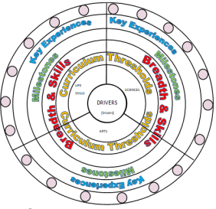
2.2 At Ryders Hayes each subject holds threshold concepts; the key disciplinary mastery aspects of each subject. They are chosen to build conceptual understanding within subjects and are repeated many times in a variety of experiences.
2.3 The threshold concepts in Mathematics are:
Connect with and understand the natural environment
Develop practical bushcraft, safety, and risk-management skills
2.4 The threshold concepts are divided into three milestones. We expect pupils in year 1 of the milestone to develop a secure understanding of the concepts and a deeper understanding in year 2 of the milestone. Phase one (Yr1, Yr3, Yr5) in a Milestone is the knowledge building phase that provides the fundamental foundations for later application. Learning at this stage must not be rushed and will involve a high degree of repetition so that knowledge enters pupils’ long-term memory. If all the core knowledge is acquired quickly, teachers create extended knowledge.
2.5 The curriculum at Ryders Hayes has three drivers chosen specifically to permeate the curriculum to meet the needs of our children and their local context.
2.6 The Curriculum Drivers for Ryders Hayes School are to:
Explore possibilities
Create independence
Build resilience
5
2.7 Through our teaching of Outdoor Learning and Forest School, we intend to:
Develop a deep appreciation and respect for nature, biodiversity, and the outdoor environment
Build physical confidence, coordination, and practical woodland skills through hands-on experiences.
Foster emotional resilience, self regulation, and confidence through supported risk taking,
encourage curiosity, scientific inquiry, and environmental stewardship across changing seasons.
Promote teamwork, social communication, and collaborative problem solving in natural settings.
Solve practical challenges using natural materials and outdoor environments creatively.
Teach risk assessment and safe tool use, empowering children to make informed decisions.
Enhance mental health, wellbeing, and sensory engagement through immersive woodland experiences.
Instill a lifelong connection to the outdoors and a passion for environmental conservation.
Integrate cross-curricular learning in science, geography, art, and literacy within natural contexts.
Provide inclusive outdoor access tailored to support varied learning styles and emotional needs.
Nurture independence, self-motivation, and holistic child development in an inspiring outdoor space.
2.8 Through Outdoor Learning and Forest School we can also:
Improve pupils' analytical and problem solving skills
Develop critical thinking and logical reasoning
Promote pupils' awareness and understanding of gender, cultural, spiritual and moral issues Develop pupils as active citizens
2.9 Entitlement and Equal Opportunities
We are committed to providing a teaching environment conducive to learning.
All pupils are entitled to access Outdoor Learning and Forest School at a level appropriate to their needs arising from race, gender, ability or disability, religion, social background and culture. We work to ensure that each child:
Achieves environmental awareness and practical confidence regardless of starting point or ability

3. Our Implementation
3.1 Organisation of the curriculum
3.11
‘Outdoor Learning and Forest School provide transformative opportunities for holistic development, fostering child led discovery, emotional growth, and a profound connection to the natural environment. Outdoor education builds resilience, teamwork, and practical problem solving skills that underpin lifelong learning, health, and wellbeing.

We believe that Forest School principles form the cornerstone of outdoor learning. Rather than treating nature as an occasional backdrop, we aim for regular, sustained outdoor experiences where pupils develop deep practical, social, and environmental awareness. At Ryders Hayes, our outdoor learning progression is cumulative - building confidence and skills year on year. To support meaningful engagement, we emphasize 3 key principles;

1. Experiential Learning & Hands-On Discovery
'Deep learning' comes from multi-sensory exploration, seasonal observation, and direct engagement with natural elements.

•Practical bushcraft - using knots, shelter building, tool work, and fire safety responsibly.

•Nature connection - observing flora and fauna, seasonal shifts, and ecosystem dynamics.

•Environmental stewardship - practicing leave no trace ethics, conservation, and habitat creation.

2. Language and communication
Outdoor settings provide an ideal context for expanding spoken language, vocabulary, and collaborative discussion. Children are encouraged to express observations, assess risks, and share strategies. Every outdoor session incorporates structured talk opportunities through:

•Sharing key vocabulary and sentence stems at the start of each task;
•Modelling respectful dialogue, active listening, and clear instruction sharing;
•Talk Tasks and paired discussions to articulate strategies;
•Plenary reviews to evaluate different methods and reasoning.

Pupils build upon environmental and practical vocabulary each year, developing sophisticated ways to describe natural phenomena, materials, and bushcraft techniques.

3. Risk Management & Independent Inquiry
- We believe in empowering pupils to manage risk safely, evaluate boundaries, and solve problems independently. We encourage children to:
- •Identify potential hazards and establish safe working zones,
- •Adapt techniques when using tools and handling natural materials,
- •Reflect on emotional reactions and build resilience in challenging outdoor conditions,
- •Select and evaluate appropriate materials and tools for outdoor tasks.

Practical problem solving lies at the core of Forest School. Whether designing weatherproof shelters, investigating habitats, or creating natural artwork, children learn perseverance through hands-on inquiry.

Outdoor Problem Solving & Risk Benefit
The Outdoor Learning curriculum treats child led exploration and risk management as central to learning. Tasks are designed to allow varied routes to solutions and promote independence and environmental awareness.

Curriculum Progression
At Ryders Hayes, our Outdoor Learning and Forest School curriculum systematically builds upon children’s prior experience. Progression maps ensure that skill development in bushcraft, ecological understanding, safety awareness, and tool use advances appropriately as pupils progress through the primary phase.

Ryders Hayes’ Outdoor Learning Progression Documents outline milestone expectations across threshold concepts. The curriculum maps align outdoor sessions with age-appropriate competencies and seasonal opportunities.

Planning and Teaching
At Ryders Hayes, each cohort engages in regular outdoor learning and Forest School sessions. Lessons follow a structured model designed to balance safety briefings, environmental exploration, talk tasks, practical skill building, and campfire reflection.

1. Welcome Circle & Safety Check
Sessions begin at the Fire Circle with site boundaries, risk-benefit discussion, safety rules, and prerequisite knowledge review for the upcoming task.

2. New Skill & Environmental Focus
Teachers demonstrate practical skills (such as knot tying, tool handling, or species identification) using explicit instruction and visual models.

3. Exploration & Child Led Inquiry
Pupils work in pairs or small groups using natural tools and materials to investigate habitats, construct shelters, or create outdoor art.

4. Practical Application & Challenge
Children complete scaffolded bushcraft or environmental tasks, progressing from basic tool use to complex design and problem solving challenges.
.
5. Reflection Circle & Storytelling
The session closes around the campfire with a review of discoveries, reflection on emotional wellbeing, site restoration, and celebration of teamwork.

Transitions
Transitions are times when pupils move between indoor classrooms and outdoor woodland spaces or between activity zones. Pupils spend time in transitions, and when outdoors, every transition is an opportunity for learning. As every moment counts in Forest School, transition activities maintain engagement and outdoor focus. Between tasks, children participate in bird call identification, nature walks, or gathering games led by staff. These activities keep pupils focused, energised, and safe during movement. It is imperative that outdoor transitions are smooth, snappy, and safe, so safety lines and boundary rules will need regular practice initially.

Forest Gatherings
Forest Gatherings take place regularly across the school to consolidate seasonal observations, environmental care, wildlife tracking, and outdoor safety principles that enrich learning outdoors.

Early Years Foundation Stage
Pupils in Reception take part in daily outdoor provision and direct Forest School sessions, building core sensory awareness, gross motor skills, confidence in nature, and physical risk management.

Key Stage Skills Progression
As pupils move into KS1 and KS2, practical tool use, shelter building, fire lighting, woodland conservation, and ecological investigations advance progressively in depth and responsibility.

Inclusion
‘All pupils progress through outdoor learning pathways at an appropriate pace, supported by scaffolded tasks, adaptive equipment, and inclusive woodland activities to ensure equity of opportunity.’

Adaptations in Outdoor Learning focus on accessible sensory trails, supportive tool grips, visual task cards, and differentiated physical tasks, ensuring every pupil experiences success regardless of prior outdoor experience.

Special Educational Needs
Children with SEN actively participate in all outdoor sessions with tailored support, extra adults, specialised clothing/equipment, and small-group woodland interventions where appropriate.

Ideas for depth
This is a tool to help teachers differentiate and challenge pupils to develop environmental reasoning and creative problem solving within outdoor concepts. Each strategy is represented by visual prompts, ensuring tasks can be easily identified by pupils in woodland settings without heavy written instruction.

Questioning
Open ended questioning in outdoor settings encourages pupils to explain observations, evaluate environmental conditions, justify material choices, and generalise natural patterns.

3.2 Supporting our Curriculum Drivers, we have our knowledge categories which provide the key knowledge within subjects and help us to grow our cultural capital; making links where appropriate to our children and their learning.

3.4 Teaching and Learning in Outdoor Learning will be in line with the school’s Behaviours for Learning Policy and outdoor safety procedures, promoting high expectations, environmental respect, and collaborative discovery.

The Outdoor Learning and Forest School curriculum at Ryders Hayes School provides rich, structured outdoor experiences that foster ecological understanding, practical bushcraft skills, and personal confidence across all key stages.
3.5 Children will undertake outdoor environmental investigations, shelter building tasks, and conservation projects to develop practical problem-solving skills.

3.6 We explore environmental and outdoor career pathways (such as forestry, ecology, conservation, landscape design, and outdoor education) with pupils to inspire future aspirations.
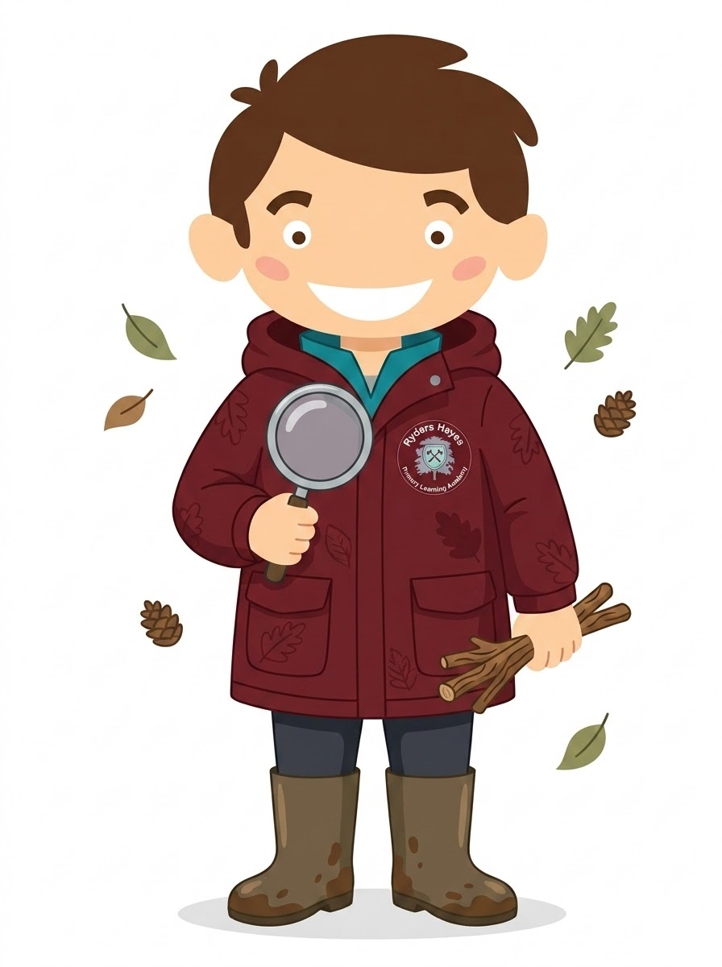
3.7 The role of the Outdoor Learning Leader is to:
Support colleagues in outdoor learning delivery, risk benefit assessments, outdoor resources, and Forest School strategies.
Maintain, audit, and organize Forest School equipment and outdoor site safety; conduct site checks and learning walks.
Oversee outdoor learning skill progression tracking and wellbeing outcomes across all year groups.
Communicate findings, ideas and resources and have an open door guidance for suggestion and questions.

4. Impact

4.1 The curriculum design and planning will lead to outstanding progress for all pupils, regardless of their starting points, over time. Learning is progressive and builds on prior knowledge and understanding and supports children in producing outcomes of the highest quality. Teaching and learning is adapted to cater for the needs of all pupils; providing support for children with special educational needs and
enrichment and challenge for more able children.
4.2 Assessing outdoor learning impact involves tracking practical skills, environmental awareness, teamwork, and confidence growth
4.3 Formative assessments, termly summative assessments, work scrutiny, and pupil conferencing are used to track progress and inform future planning.
4.4 Pupil voice interviews are conducted regularly to measure confidence, mathematical attitude, and understanding of concepts.

Resources
4.5 Outdoor learning resources are maintained in outdoor stores and designated Forest School site sheds. Equipment includes: hand tools, tarpaulins, ropes, fire safety kit, field guides, magnifiers, bug pots, and weather gear.
4.6 Sourcing, inspecting, and replenishing outdoor resources and safety apparatus remains the responsibility of the Outdoor Learning Leader.
Monitoring and Evaluation
4.8 Monitoring includes book scrutiny, lesson observations, pupil voice evaluations, and learning walks aligned with the School Development Plan.
4.9 The Outdoor Learning Leader evaluates curriculum impact to ensure pupils gain robust outdoor skills, ecological understanding, and personal resilience.
9

