Ryders Hayes School
A Primary Learning Academy
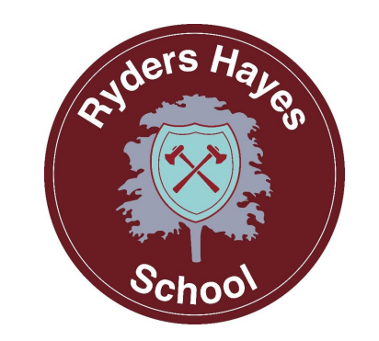

Music Guidance

Ryders Hayes School
Gilpin Crescent
Pelsall
Walsall
WS3 4HX
01922 683008
postbox@ryders-hayes.co.uk

Music Leader - Jenny Holmes

INTRODUCTION:

Musical education forms a fundamental element of the curriculum at Ryders Hayes School. As a universal form of expression, music enables pupils to nurture self-confidence, explore creative potential, and cultivate personal style. We aim to deliver exceptional musical opportunities for all pupils—from Nursery through to Year 6—to inspire enthusiasm and foster an enduring appreciation for music.

OUR INTENT:
Ryders Hayes offers the music curriculum through Charanga’s creative curriculum, spanning Nursery through Year 6 that integrates digital tools directly into everyday lessons.
Key Features of the Creative Curriculum
- Built-in Digital Technology: Features ‘YuStudio’ Charanga's cloud-based Digital Audio Workstation (DAW), embedded into lessons so children can create digital music and add sound effects.
- Progression and Structure: Offers weekly-planned activities with straightforward planning support, combining listening, singing, improvising, composing, and playing instruments.
- Key Stage 2 Composition Units: Includes five dedicated KS2 composition units using YuStudio to prepare pupils for secondary-level music technology.
- Built-in Differentiation: Provides practical guidance for less-confident learners and extension tasks for advanced students without adding extra workload for teachers.
- Flexible Planning & Support: Fits any teaching style or timetable and comes with CPD and training support, custom scheme builders, and interactive on-screen resources

Through our teaching of Music, we intend to:

⮚ Stimulate pupils' enthusiasm, engage and inspire them to develop a love of Music and so increase their self-
confidence, creativity and sense of achievement.

⮚ Increase their knowledge and understanding of the different communities and cultures within Ryders Hayes, Pelsall, Walsall, Britain and the world around them - and how these relate to each other and promote British Values.

⮚ Increase pupils’ knowledge and understanding in order for them to develop a critical engagement with music.

⮚ Allow pupils to perform, listen to, review and evaluate music across a range of historical periods, genres, styles and traditions.

⮚ Develop pupils' competence in specific musical skills (such as learning to sing and being able to use their voices, to create and compose music, to improvise and to develop skills on a range of musical instruments, including the opportunity to learn the ukulele in Y4, a brass or woodwind instrument in Y5, a variety of authentic world, music instruments in Y6 and the use of ICT in music).
⮚ Foster a sense of responsibility and respect for our school resources.

Through Music we can also:

⮚ Improve pupils' skills in English, Maths and ICT
⮚ Develop pupils' thinking and creative skills
⮚ Promote pupils' awareness and understanding of gender, cultural, spiritual and moral issues
⮚ Develop pupils as active citizens who perform regularly within the local community (as part of the choir, band,
ukulele group or in whole school activities such as Harvest and Carol Services)
⮚ Promote awareness of Music related careers

Entitlement and Equal Opportunities:

We are committed to providing a teaching environment conducive to learning.
All pupils are entitled to access the Music curriculum at a level appropriate to their needs arising from race, gender, ability or disability, religion, social background and culture. Extra-curricular music making is open to all. Pupil premium pupils have free access to instrumental lessons and can borrow an instrument from school free of charge. We work to ensure that each child;

⮚ Achieves the best possible academic and performing standards in Music regardless of starting point or ability
⮚ Experiences and explores music making in a real-life context
⮚ Understands how they have the opportunity to progress to the next level of musical excellence.
⮚ Develops an awareness of other music from other cultures and, in doing so, achieves respect, tolerance and understanding of what it means to be a positive citizen in a multicultural country embedding the fundamental British values.

Organisation of Music within the Curriculum

Music is linked to all subjects including History, RE and Science, Me and My World, ICT, Maths and English through the use of cross curricular writing and listening, composing and performing.
Additionally, Music is part of the Arts Focus for learning. This enables Geography, History, English, RE, Languages, Art and Music to work together sharing best practice, modelling and supporting excellence and holding each other to account for our Subject Lead responsibilities.

Our Implementation

Teaching and Learning in Music will be in line with the school’s Behaviours for Learning Policy, where provision is made for all learning styles. The Music curriculum at Ryders Hayes School is designed to provide children with learning opportunities that reflect the breadth and balance of contexts outlined in the National Curriculum, as well as well-planned repetition to ensure a
secure foundation of Musical knowledge and skills.

As an integral part of the teaching and learning of Music children will be given the opportunity to listen to and participate in high quality performances both at school and at other venues such as the Birmingham Hippodrome and Walsall Arena (Music Hub).

We are very proud of our extensive calendar of events, including a weekly music assembly, which help children learn performance skills and to respect the school and wider community.

We display and share the characteristics of a Musician, as well as investigating career opportunities, with children at every available opportunity.
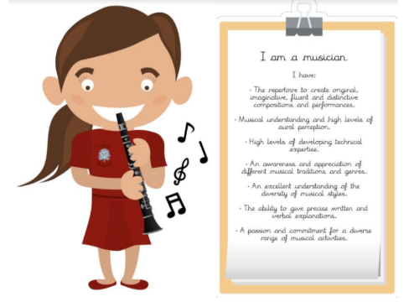

Key Experiences:

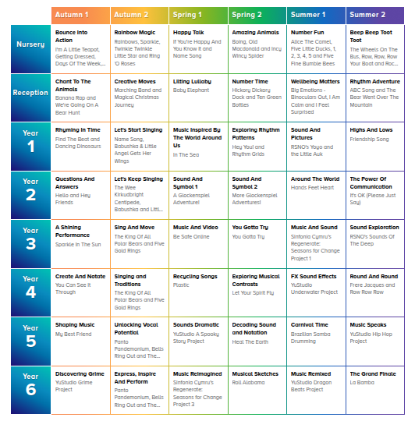

The role of the Music Leader is to:

⮚ Support the teaching and learning from Reception-Year 6 and continually monitor the planning, delivery and assessment of music by networking with Charanga, regular updates and collaborating with external professionals to maintain a smooth, communicative environment.
⮚ Renew, update and oversee the audit of resources needed to deliver the curriculum
⮚ Monitor and evaluate the learning and teaching through reflective practice.
⮚ Develop assessment and record keeping ensuring progression and continuity
⮚ Communicate findings, ideas and resources and have an open-door policy for suggestion and questions.

