Ryders Hayes School
A Primary Learning Academy

Maths Guidance

Ryders Hayes School
Gilpin Crescent
Pelsall
Walsall Alison Jackaman
WS3 4HX
01922 683008 Maths Leader
postbox@ryders-hayes.co.uk

Mission: At Ryders Hayes School, children and staff will strive to:

Vision: To inspire a lifelong love for Maths through engaging learning that builds step-by-step foundations, placing reasoning and problem-solving at the heart of real-world success

Character: qualities of the individual essential for being personally effective in a complex world including: grit, tenacity, perseverance, resilience, independence, reliability and honesty.
Citizenship: upholding British Values, thinking like global citizens, considering global issues based on deep understanding of diverse values with genuine interest in engaging with others to solve complex problems that impact human and environmental sustainability
Collaboration: the capacity to work interdependently and synergistically in teams with strong interpersonal and team-related skills including effective management of team dynamics, making substantive decisions together, and learning from and contributing to the learning of others.
Communication: entailing mastery of three fluencies: digital, writing and speaking tailored for a range of audiences, through early, high-quality back and forth interaction.
Creativity: having an ‘entrepreneurial eye’ for economic and social opportunities, asking the right questions to generate novel ideas and explore possibilities, demonstrating leadership to pursue those ideas into practice.
Critical Thinking: critically evaluating information and arguments, reflecting upon them, seeing patterns and connections, constructing meaningful knowledge and applying it in the real world.

Ryders Hayes is a Gold Rights Respecting School and as such strongly believes in and promotes the United Nations Convention on the Rights of the Child. All our policies exemplify these rights and our practise aims to ensure that the following rights are adhered to.
Article 3: The best interests of the child must be a top priority in all things that affect children. Article 12: Every child has the right to have a say in all matters affecting them, and to have their views taken seriously.
Article 13: Every child must be free to say what they think and seek and receive all kinds of information, as long as it is within the law.
Article 14: Every child has the right to think and believe what they want and to practice their religion, as long as they are not stopping other people from enjoying their rights. Governments must respect the rights of parents to give their children information about this right.
Article 19: Governments must do all they can to ensure that children are protected from all forms of violence, abuse, neglect and bad treatment by their parents or anyone else who looks after them.
Article 28: Every child has the right to an education. Primary education must be free. Secondary education must be available for every child. Discipline in schools must respect children’s dignity. Richer countries must help poorer countries achieve this.
Article 29: Education must develop every child’s personality, talents and abilities to the full. It must encourage the child’s respect for human rights, as well as respect for their parents, their own and other cultures, and their environment.
Article 30: Every child has the right to learn and use the language, customs and religion of their family, regardless of whether these are shared by the majority of the people in the country where they live.
Article 36: Governments must protect children from all other forms of bad treatment.

INTRODUCTION

1.1 The School seeks to promote behaviour based on mutual respect between all members of the School community. Ryders Hayes aims to:
….nurture and facilitate the growth of our pupils and their learning; equipping them with the skills and attributes to embrace the challenges of a rapidly changing world. To enjoy success for today and be prepared for tomorrow, by instilling the values of: enquiry; adaptability; resilience; morality; effective communication; thoughtfulness; collaboration; respect; international /open mindedness and a growth mind-set.
1.2 This guidance outlines the learning, teaching, organisation and management of Maths at Ryders Hayes School.
1.3 The implementation of this guidance is the responsibility of all teaching staff. The responsibility for monitoring and review rests with the Maths Leader- Jack Phillips.
1.4 The curriculum is designed to build a schema by developing knowledge and vocabulary through a range of topics and deliberate practice.

2. Our Intent

2.1 Ryders Hayes Curriculum Model
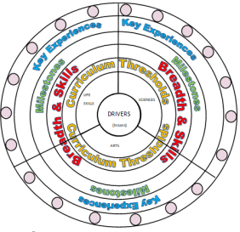
2.2 At Ryders Hayes each subject holds threshold concepts; the key disciplinary mastery aspects of each subject. They are chosen to build conceptual understanding within subjects and are repeated many times in a variety of experiences.
2.3 The threshold concepts in Maths are:
Mathematical Reasoning
Mathematical Fluency
2.4 The threshold concepts are divided into three milestones. We expect pupils in year 1 of the milestone to develop a secure understanding of the concepts and a deeper understanding in year 2 of the milestone. Phase one (Yr1, Yr3, Yr5) in a Milestone is the knowledge building phase that provides the fundamental foundations for later application. Learning at this stage must not be rushed and will involve a high degree of repetition so that knowledge enters pupils’ long-term memory. If all the core knowledge is acquired quickly, teachers create extended knowledge.
2.5 The curriculum at Ryders Hayes has three drivers chosen specifically to permeate the curriculum to meet the needs of our children and their local context.
2.6 The Curriculum Drivers for Ryders Hayes School are to:
Explore possibilities
Create independence
Build resilience
5
2.7 Through our teaching of Maths, we intend to:
Develop children’s fluency with basic number facts
Develop children’s fluency in mental calculation
Develop children’s fluency in the use of written methods
Develop children’s understanding of the = symbol
Teach inequality alongside teaching equality
Don’t count, calculate
Look for pattern and make connections
Use intelligent practice
Expose mathematical structure and work systematically
Move between the concrete and the abstract
Contextualise the mathematics
Use questioning to develop mathematical thinking
Expect children to use correct mathematical terminology and speak in full sentences
Identify difficult points
2.8 Through Maths we can also:
Improve pupils' skills in English, Maths and Computing
Develop pupils' thinking skills
Promote pupils' awareness and understanding of gender, cultural, spiritual and moral issues Develop pupils as active citizens
2.9 Entitlement and Equal Opportunities
We are committed to providing a teaching environment conducive to learning.
All pupils are entitled to access the Maths curriculum at a level appropriate to their needs arising from race, gender, ability or disability, religion, social background and culture. Class work may have to be adapted to take into account individual requirements. We work to ensure that each child
Achieves the best possible academic standards in Mathematics regardless of starting point or ability

3. Our Implementation
3.1 Organisation of the curriculum
3.11
‘Mathematics is an interconnected subject in which pupils need to be able to move fluently between representations of mathematical ideas. The programmes of study are, by necessity, organised into apparently distinct domains, but pupils should make rich connections across mathematical ideas to develop fluency, mathematical reasoning and competence in solving increasingly sophisticated problems. They should also apply their mathematical knowledge to science and other subjects.’ (National curriculum 2013)

We believe the ‘mastery approach’ to teaching maths is the underlying principle of mastering Mathematics. Instead of learning mathematical procedures by rote, we want pupils to build a deep conceptual understanding of concepts which will enable them to apply their learning in different situations. At Ryders Hayes, we follow the Mathematics Mastery programme where the curriculum is cumulative - each school year begins with a focus on the concepts and skills that have the most connections, which are then applied and connected throughout the school year to consolidate learning. This gives pupils the opportunity to ‘master maths’; by using previous learning throughout the school year, they are able to develop mathematical fluency and conceptual understanding. To avoid teaching procedures we encourage pupils to develop a deep understanding in mathematics through 3 key principles;

1. Conceptual understanding
'Deep understanding' in maths is being able to represent ideas in many different ways using objects and pictures to represent abstract concepts. Mathematics Mastery uses the Concrete-Pictorial-Abstract (CPA) approach in order for pupils to develop a deep understanding. Reinforcement of learning is achieved by going back and forth between these representations, building pupils' conceptual understanding instead of an 'instrumental understanding'.

•Concrete - the doing: A pupil is first introduced to an idea or a skill by acting it out with real objects. This is a 'hands on' component using real objects and it is the foundation for conceptual understanding. Concrete refers to objects such as base ten, fraction tiles, markers, or other objects that can be physically manipulated.

•Pictorial - the seeing: When a pupil has sufficiently understood the hands-on experiences performed, they can now relate them to pictorial representations, such as a diagram or picture of the problem.

•Abstract - the symbolic: A pupil is now capable of representing problems by using mathematical notation, for example: 12 ÷ 2 = 6. This is the most formal stage of mathematical understanding. Abstract representations can simply be an efficient way of recording the maths, without being the actual maths. We believe the meaning of symbols must be firmly rooted in experiences with real objects; otherwise it becomes rote repetition of meaningless memorised procedures.

2. Language and communication
The national curriculum for Mathematics reflects the importance of spoken language in pupils’ development across the whole curriculum – cognitively, socially and linguistically. The quality and variety of language that pupils hear and speak are key factors in developing their mathematical vocabulary and presenting a mathematical justification, argument or proof. They must be assisted in making their thinking clear to themselves as well as others. (National Curriculum 2013) We believe that pupils should be encouraged to use mathematical language and full sentences throughout their maths learning to deepen their understanding of concepts. The way pupils speak and write about mathematics has been shown to have an impact on their success in Mathematics (Morgan, 1995; Gergen, 1995). Therefore, we should use a carefully sequenced, structured approach to introducing and reinforcing mathematical vocabulary throughout maths lessons, so pupils have the opportunity to work with word problems from the beginning of their learning. Every Mathematics Mastery lesson provides opportunities for pupils to communicate and develop mathematical language through:

•Sharing the key vocabulary at the beginning of every lesson in the ‘Star Words’ section, and insisting on its use throughout;
•Modelling clear sentence structures and expecting pupils to respond using a full sentence;
•Talk Task activities, allowing pupils to discuss their thinking and reasoning of the concepts being presented;
•Plenaries which give a further opportunity to assess understanding through pupil explanations.

Pupils should revisit mathematical language from previous years and explore the concepts in greater depth. There should be opportunities for pupils to clarify vocabulary and explore activities that develop an understanding of the different concepts.

3. Mathematical thinking
We believe it is essential for pupils to develop mathematical thinking in and out of the classroom in order to fully master mathematical concepts. We want children to think like mathematicians, not just DO the maths. We believe that pupils should:
- •Explore, wonder, question and conjecture,
- •Compare, classify, sort,
- •Experiment, play with possibilities, vary an aspect and see what happens,
- •Make theories and predictions and act purposefully to see what happens,
- generalise.

It is important that we support all pupils in developing their mathematical thinking, both in order to improve the way in which they learn, as well as the learning itself. Good questioning should be used to develop pupils’ ability to compare, modify and generalise, all building a deeper understanding of mathematics. Problem solving ‘Pupils can solve problems by applying their mathematics to a variety of routine and non routine problems with increasing sophistication, including breaking down problems into a series of simpler steps and persevering in seeking solutions.’ (National Curriculum 2013)

Problem solving
The Mathematics Mastery Programme places problem solving at the heart of the curriculum as the essence of everything we do as mathematicians. Problem solving should not be an add-on at the end of a maths lesson or a weekly investigation lesson. We believe that a problem-solving approach is the key to mathematical success, and should be used continually throughout lessons to build on depth of understanding. Pupils should be given every opportunity to explore, recognise patterns, hypothesise and be empowered to let problem solving take them on new and unfamiliar journeys. Even the most straight-forward of tasks can be an opportunity for pupils to investigate, seek solutions, make new discoveries and reason about their findings.

The diagram below shows the dimensions for depth that our curriculum provides with problem solving at the heart of it

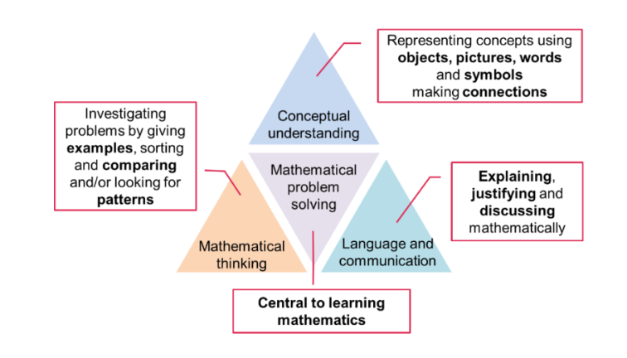
Curriculum Progression
At Ryders Hayes, we follow the Mathematics Mastery resourced curriculum which has been created following the guidance set out in the Mathematics National Curriculum using curriculum maps, programmes of study and key representations for each year group - it ensures that progression is catered for as children move through the Primary Phase. The units systematically build upon children’s prior knowledge, developing their understanding of each Mathematical concept and the links that can be made.

Ryders Hayes’ Progression Documents have also been created, which are used in conjunction with the Mathemtics Mastery Resourced curriculum. The documents feature each threshold concepts (Mathematical overarching concepts). The document follows a progression of skills which have been matched to each year group’s unit. The majority of threshold concepts are taught in all year groups; this allows pupils to revisit the topic, recap prior learning and then deepen their understanding. The Progression in Calculation document outlines the key skills and the different calculation strategies that should be taught and used in Years 1 to 6 in line with requirements of the Primary National Curriculum .The Calculation Policy is intended to be embedded as Mathematics Mastery programme is rolled out year on year to each cohort of pupils.

Planning and Teaching
At Ryders Hayes each year group (from Year 1-6) teaches at least 5 Maths lessons per week (lasting between 1hour – 1hour 15min). Teachers follow a 6 part lesson structure although teachers have the flexibly to adapt this to suit the needs of the children as long as the three key principles of language and communication, conceptual understanding and Mathematical thinking are incorporated.

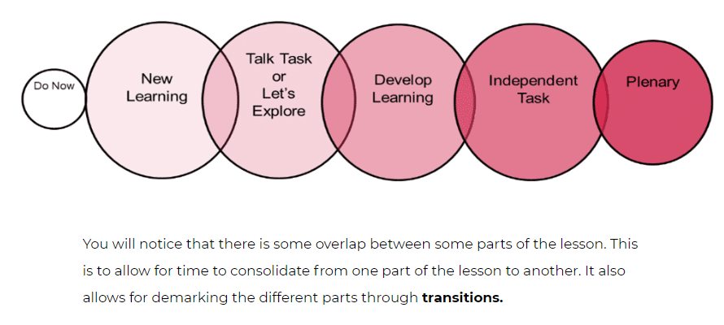

1. Do Now Task
The purpose of the ‘Do Now’ task is to consolidate previous learning. This could be recapping on what was learnt the day before or a topic from a previous unit that is necessary for the current lesson. Do Now tasks can be independent work that the children do about 5 minutes or a guided task with an adult to clarify misconceptions.

2. New Learning
The New Learning section introduces the main learning for the lesson, beginning by sharing the lesson’s key vocabulary (Star Words). It is expected that this segment will require clear explanations and modelling. The New Learning section usually lasts around 15 minutes, and may involve partner discussions and answering questions, so teachers can check pupils’ understanding before moving onto the next parts of the lesson. If children are at different starting points for the lesson a TA may be used to differentiate the new learning.

3. Talk Task
As language is such an important feature of Mathematics Mastery, Talk Tasks are imperative. This segment allows talking about maths and comprehension to be developed, and provides opportunities to use mathematical language. The main focus here is on the children working together in pairs or small groups and talking in full sentences about maths. Developing pupils’ language is an important feature of the Mathematics Mastery approach, and taking turns and listening are important to children’s development. Pupils will need training in how Talk Tasks will look. Ensure that you are always using the correct language structures when modelling questions and responses, and insist that pupils respond fully at all times when they are replicating your language use. Assessment of understanding should take place during this segment by listening to pupils’ explanations and discussions.

4. Develop Learning
The Develop Learning segment should mirror the New Learning earlier in the lesson, but aims to move the pupils’ learning on further and deepen their understanding. Learning could be developed by introducing different resources, adding a problem solving element, or encouraging further good language use following the Talk Task. This is a great opportunity to assess progress and understanding, and deal with any common misconceptions before pupils start independent work
.
5. Independent Task
This segment should give pupils the opportunity to practise their Develop Learning by working independently and demonstrating what they have understood and learnt. Although this is an independent task, this does not mean that the children must work alone, in silence, as they should be encouraged to discuss mathematical concepts together using the key vocabulary of the lesson. Here, tasks will often need to be adapted so they challenge everyone in the class. Teachers will need to consider how they can deepen mathematical thinking for those pupils who have accessed the learning with ease. Whilst the pupils are working independently, teachers should assess progress to pick up on any pupils that are struggling, or need additional challenge and to direct how the plenary will be used.

6. Plenary
The final part of the lesson should be used to reflect on learning, gather evidence for assessments and plan for future learning. It should sum up what the children have learnt during the lesson, consolidating all learning, address any common misconceptions, and may pose a question for the next lesson.

Transitions
Transitions are times when pupils move from place to place or activity to activity. Pupils spend a lot of time in transitions – by necessity – and when they are in transitions they are always learning. As every second counts in a Mathematics Mastery lesson, transition activities are a very important component. Between tasks, children sing songs or do call and response activities with the teacher. These activities are exciting for the pupils, and helps to keep them focused on the learning and the lesson flowing. It is imperative that the transitions are smooth, snappy and meaningful, so these will need a lot of practice initially. Although these may seem repetitive at first, this repetition will aid learning, and eventually each lesson will use a variety of transitions.

Maths Meetings
Maths Meetings are a vital part of the Mathematics Mastery programme, used to consolidate key learning for 10-15 minutes at least 3 times a week outside of the maths lesson. Maths Meetings provide an opportunity to teach and revise 'general knowledge maths' which may not explicitly be covered during the maths lesson, and also allows the daily integration of maths into the surrounding environment. This means that pupils are practicing concepts and skills on a regular basis, meaning they are continually building on their mastery of these concepts. Maths Meetings should be a positive part of the day which everyone looks forward to and pupils should be fully engaged with. Calendar maths and place value should be included in every Maths Meeting and the rest of the meeting should change regularly according to the topics you wish to revise and consolidate. Maths Meetings are used in all year groups within our school, as it gives the teacher opportunities to reinforce and consolidate key areas of the curriculum, and also allows time to introduce topics and concepts that may be part of the next unit. Times Tables Times table recall has always been a vital contributor to the success of our learners. Times tables are used throughout the maths curriculum, and day-to-day life, so we ensure that the practice of such a skill is embedded throughout the school.

Mastering Number
Pupils in Year R-2 take part in NCETM Mastering Number sessions. For Reception, these sessions form the basis of their Maths session. In KS1, they are extra to the Maths lesson. These focus on addition and subtraction facts to 20 whilst securing a deep conceptual understanding.

Fact Foundations
Pupils in Years 3 and 4 take part in Fact Foundation sessions , twice weekly. This focuses on multiplication facts. IT teaches the facts, but also teaches conceptual understanding alongside this.

Inclusion
‘The expectation is that the majority of pupils will move through the programmes of study at broadly the same pace. However, decisions about when to progress should always be based on the security of pupils’ understanding and their readiness to progress to the next stage. Pupils who grasp concepts rapidly should be challenged through being offered rich and sophisticated problems before any acceleration through new content. Those who are not sufficiently fluent with earlier material should consolidate their understanding, including through additional practice, before moving on (National Curriculum, 2013)

We fully support the idea that adaptation should not be through accelerating through the curriculum or task modification in the traditional sense but that adaptations should be carefully planned and come from the three principles of Mathematics Mastery (see above) . Pupils should be encouraged to explore and investigate topics in greater depth, so they build a stronger understanding of the main maths concepts within that topic. We believe that in order to make adaptation successful, teachers should tailor tasks to suit the needs of their pupils. Adaptations should be built into the lesson resources by the teacher, as they know their pupils’ progress and understanding best. Some children will have gaps in their learning especially in upper KS2 and adaptations will need to take account of this. Some children will need to build up to the main objective for the lesson by initially working through the ‘learning steps’ which may come from previous year groups. In order to successfully engage with the Mathematics Mastery programme resources and provide appropriate support and challenge for all of our pupils, it is essential that staff adapt. . Adaptation should involve the adaptation of tasks and learning opportunities so that all pupils can access the same principle. Scaffolding and constraints, 'intelligent' task design and rich Low Threshold High Ceiling tasks will ensure that every child succeeds in mathematics.

Special Educational Needs
Children with SEN are taught within the daily mathematics lesson and are encouraged to take part when and where possible through differentiation meeting the needs from their PLP’s. In some instances this may mean personalised activities and learning. When additional support staff are available to support groups or individual children they work collaboratively with the class teacher and feedback information on progress throughout the lesson.

Ideas for depth
This is a tool to help teachers differentiate and challenge pupils to develop a mathematical thinking and reasoning within a concept. Each of the ten ideas are represented by a picture or symbol, meaning after introduction, the tasks can be easily identified by pupils without the need for written instruction.

Questioning
Questioning plays a crucial role in developing mathematical thinking, by helping students to identify thinking processes, making connections between ideas and building new understanding. It is important that staff adapt the Mathematics Mastery Lesson Guides to include their own questioning based on the needs of their pupils. It is really important to model good questions and answers in lessons. Pupils should be encouraged to speak in full, correct sentences and should be prepared to explain and justify answers when prompted. When Pupils struggle with this it can be tempting to think or say “I know what you’re trying to say…” and to move on, but this is not encouraged. Pupils should be pushed to explain themselves with clarity and precision as much as possible. Questioning is a useful way of engaging, supporting and challenging students. In this context, good questions would prompt new thinking, probe understanding and promote discussion, pushing students outside of their comfort zone. Rather than accepting a given answer, teachers can always probe further by asking ‘how’ and ‘why’ questions. Open questions can be used to elicit responses from students that move beyond simply carrying out a calculation or procedure. Using open questions allows students to develop their thinking and problem solving skills and allows the teacher to make a more informed judgement about current understanding and misconceptions

3.2 Supporting our Curriculum Drivers, we have our knowledge categories which provide the key knowledge within subjects and help us to grow our cultural capital; making links where appropriate to our children and their learning.

3.4 Teaching and Learning in Maths will be in line with the school’s Behaviours for Learning Policy, where provision is made for all learning styles.

The Maths curriculum at Ryders Hayes School is designed to provide children with learning opportunities that reflect the breadth and balance of contexts outlined in the National Curriculum, as well as well-planned repetition to ensure secure foundation of Maths knowledge and skills.
3.5 As an integral part of the teaching and learning of Mathematics children will be given the opportunity to undertake purposeful problem solving, communicating their findings in a variety of ways.

3.6 We display and share the characteristics of a Mathematics Learner, as well as investigating career opportunities, with children at every available opportunity.

3.7 The role of the Maths Leader is to:
Support colleagues in teaching the subject content and developing their skills in planning, teaching and assessing Maths
Renew, update and oversee the audit of resources needed to deliver the curriculum Monitor and evaluate the learning and teaching of Maths through learning walks and book trawls
Develop assessment and record keeping ensuring progression and continuity
Communicate findings, ideas and resources and have an open-door guidance for suggestion and questions

4. Impact

4.1 The curriculum design and planning will lead to outstanding progress for all pupils, regardless of their starting points, over time. Learning is progressive and builds on prior knowledge and understanding and supports children in producing outcomes of the highest quality. Teaching and learning is adapted to cater for the needs of all pupils; providing support for children with special educational needs and
enrichment and challenge for more able children.
4.2 Assessing the impact of the teaching will be completed termly by teachers and this will be used to assess curriculum overviews for each age group, and these will be based on Mathematics Mastery assessments
4.3 Methods of assessment will vary as appropriate to the learning in lessons. Pre and Post unit quizzes will be taken before and after each unit of work to inform future planning. A book sample will be carried out regularly to gain an idea of children’s starting points and to show the progress made in the term.
4.4 In Maths pupil voice will be used by the subject leader to assess the progress in understanding and applying skills needed to become a Mathematician.

Resources
4.5 Maths resources are stored in classrooms and some are centrally stored in the Maths leader’s classroom. . Children will have the opportunity to use the following resources: Diennes, counters. Rekenreks, Cuisenaire rods, geoboards, clocks, money, cubes, 3D shapes, scales, protractors, measuring equipment
4.6 If new or additional resources are required this is the responsibility of the Maths Leader to source as well as replenish necessary resources.
Health and Safety
4.7 This guidance needs to be read alongside our Health and Safety Policy. Consideration needs to be given to conducting appropriate Risk Assessments and ensuring the safeguarding of children and staff when planning and carrying out Maths activities.
Monitoring and Evaluation
4.8 The teaching and learning of Maths will be monitored through the analysis planning, pupil voice interviews, analysis of assessment data, scrutiny of work samples, completion and recording of Maths tasks to assess skills and knowledge and learning walks, in line with the School Development Plan.
4.9The Maths leader will evaluate progress that has been made and the impact of the curriculum to ensure all pupils have been taught the knowledge and skills they need to deepen their mathematical understanding.
9

Appendix 1 - Whole School Plans
Autumn
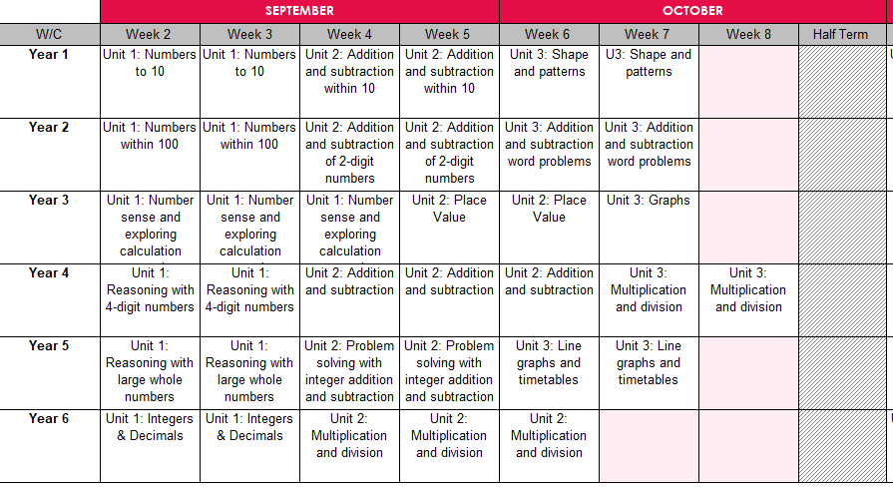
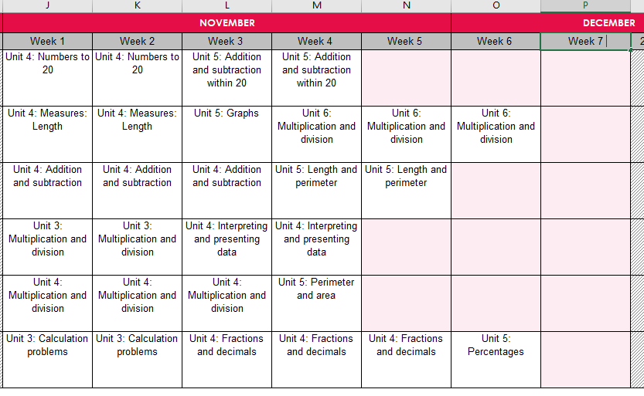
Spring
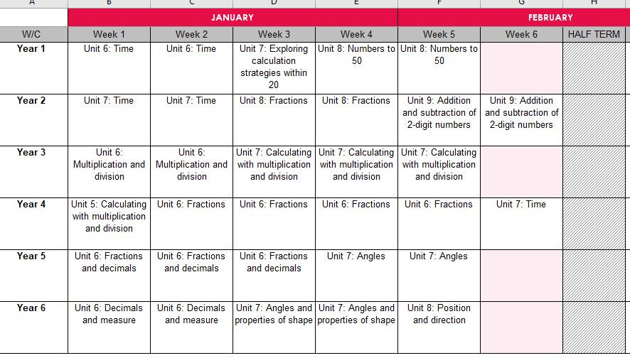
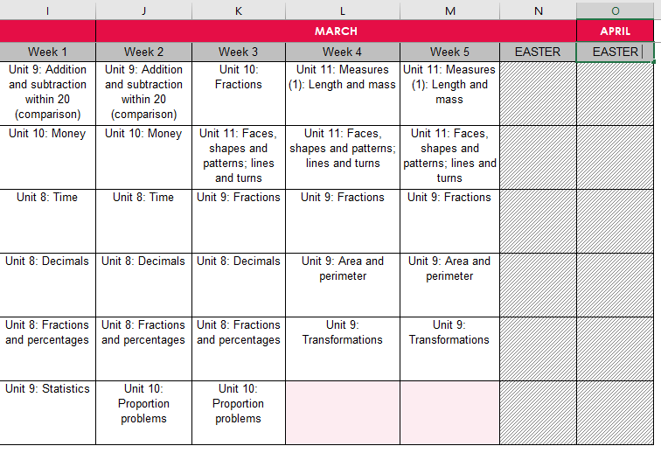
Summer
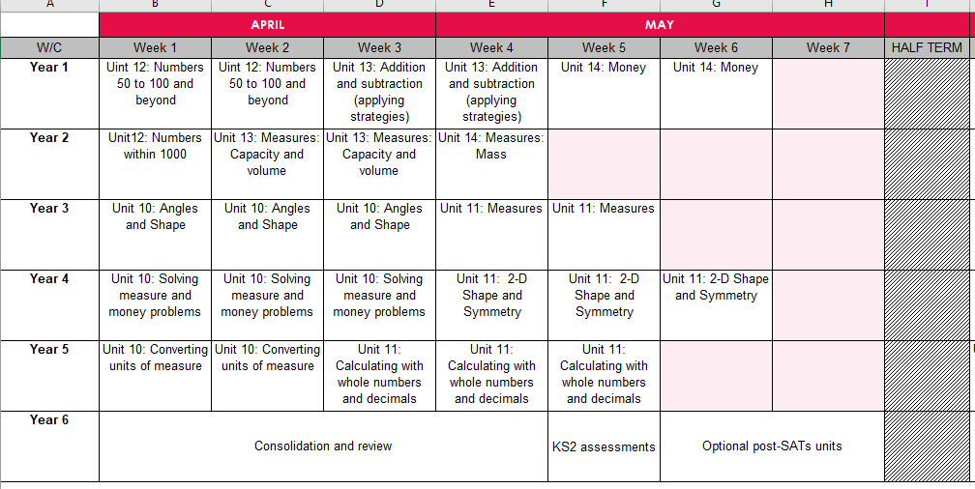
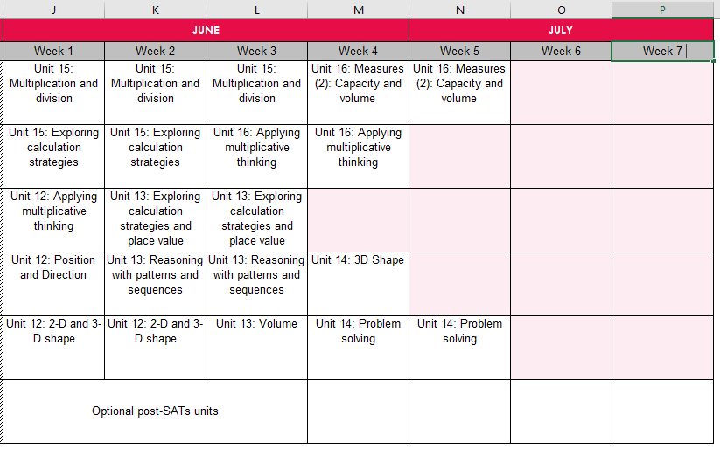
Year Group Plans
