Ryders Hayes School
A Primary Learning Academy



Guidance for Design Technology

Ryders Hayes School
Gilpin Crescent
Pelsall
Walsall
01922 683008
postbox@ryders-hayes.co.uk N.Smith 2026

Guidance for Design and Technology

Our School Vision

To inspire children to become autonomous, creative problem-solvers who can shape the world around them. By combining practical skills with critical thinking, pupils are empowered to design and make products that solve real and relevant problems within a variety of contexts.

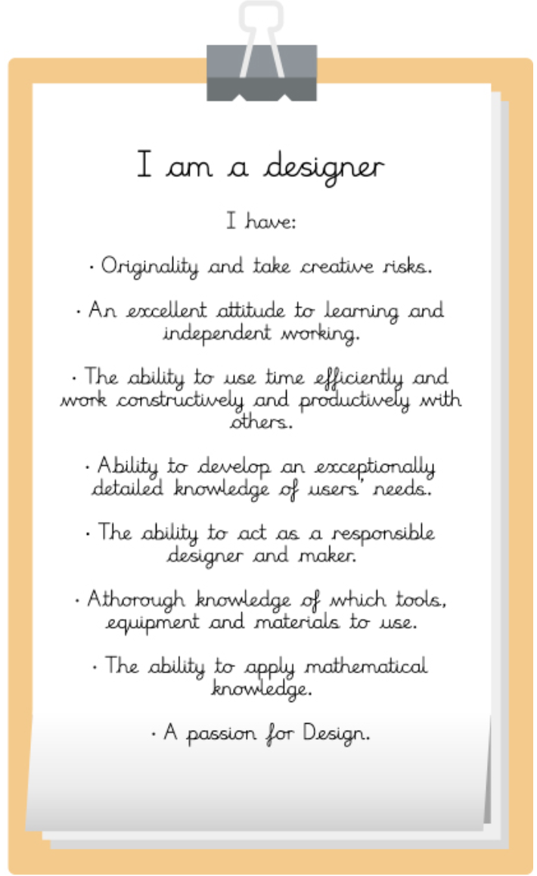

Our Intent:
- To inspire children to become creative, critical, and autonomous problem-solvers who can shape the physical and digital world around them.
- To equip every child with the technical knowledge, practical skills, and confidence to transform abstract ideas into authentic, functional products.
- To send children into the world as empathetic, responsible, and resourceful citizens equipped for an ever-evolving technological landscape.

Our Implementation:
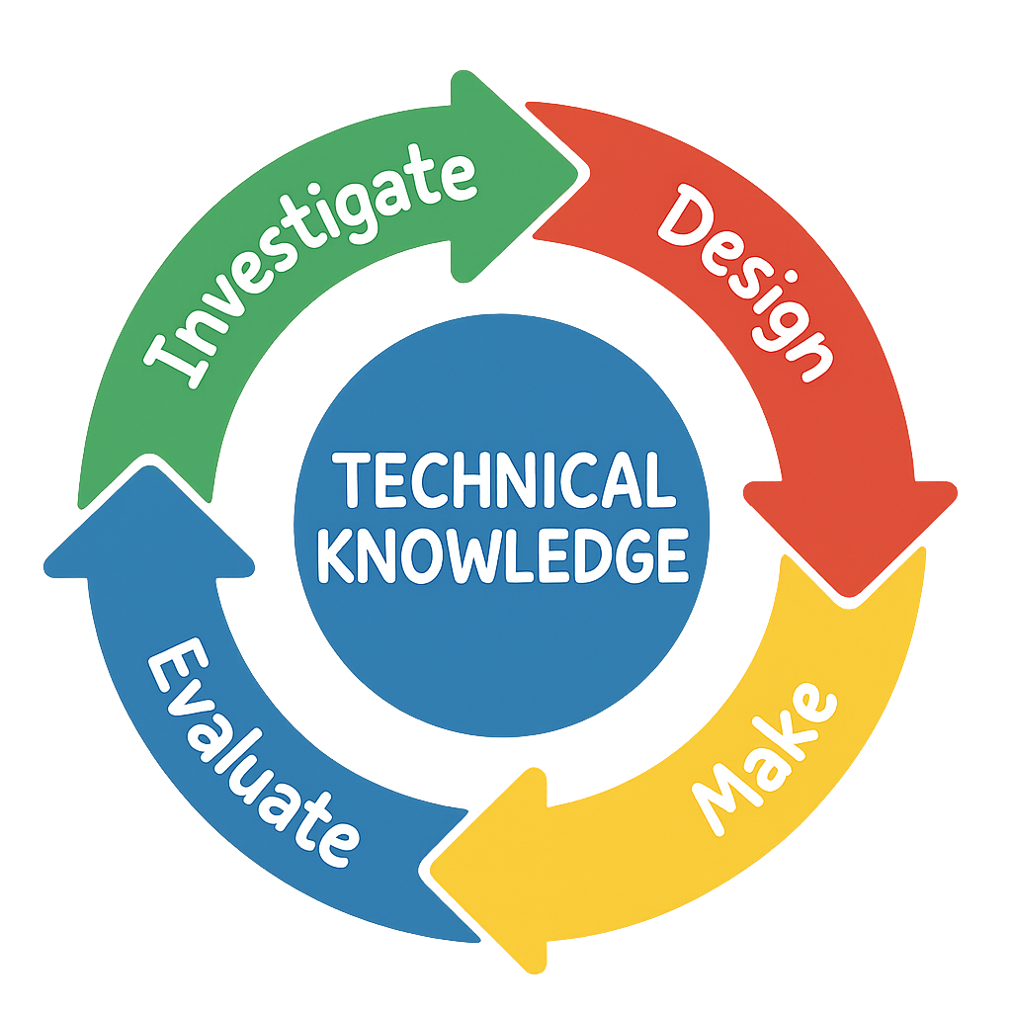
- Strands: Children begin by investigating existing products and real-world contexts, developing a critical eye for how objects are made and used. This inquiry is underpinned by targeted technical knowledge, where children explicitly learn about the properties of materials, structural stability, mechanical systems, electrical circuits, and food hygiene. Drawing on this foundation, children design purposeful, functional products for specific users, generating ideas through sketches, CAD, and physical prototypes. During the make phase, children select and safely apply a growing repertoire of tools, equipment, and joining techniques to realize their designs with increasing accuracy and precision. Finally, children continuously evaluate their work against their original design criteria, testing performance, refining prototypes, and reflecting on how well their finished product meets the needs of the end-user.
- Content: From Early Years and Key Stage 1, children engage with cooking and nutrition by preparing healthy dishes using basic food techniques, while discovering the principles of structures by constructing stable shell and frame shapes. They explore physical movement through mechanisms, progressing from simple levers and sliders to complex wheels, axles, gears, and pulleys. Children also develop working knowledge of textiles, learning to join, pattern, and stitch fabrics to create functional products. As children move into Key Stage 2, the curriculum incorporates electrical systems, teaching children to integrate series circuits, switches, sensors, and buzzers into their functional builds. Finally, Key Stage 2 extends into the digital world, where children harness computer-aided design (CAD), micro:bits, and basic coding to program, monitor, and control their physical designs, ensuring they are equipped for a rapidly evolving technological landscape.
- Key Principles: Learning is driven by authenticity, ensuring children address genuine challenges rather than producing superficial craft items. Central to every project are the intended user and clear purpose, requiring children to consider real needs, context, and practical functionality over mere aesthetics. As children progress, they are empowered to make autonomous design decisions—selecting materials, tools, and joining methods based on prior testing rather than rigid, step-by-step instructions. This freedom fosters innovation, encouraging children to take calculated risks, embrace creative problem-solving, and develop unique solutions. Finally, embedded throughout the curriculum is a focus on sustainability, teaching children to critically consider material lifecycles, ethical sourcing, and environmental impact, shaping them into responsible makers for the future.

Our Intended Impact:

- Technical competency and long-term knowledge retention: Children develop a progressive repertoire of practical skills, moving from using safety scissors and split pins in Key Stage 1 to confidently and safely handling knives, wire strippers, and CAD software by the end of Key Stage 2. Throughout this journey, pupils build a deep subject vocabulary, allowing them to articulate their design choices using precise technical terminology across all six content domains. Ultimately, this accumulated knowledge ensures pupils consistently produce high-quality, authentic, and fully functional products tailored to a specific user, purpose, and sustainable footprint, rather than superficial craft items.
- Independence, resilience, and executive function: Rather than relying on step-by-step teacher direction, children make autonomous, evidence-based decisions about tools, materials, and joining methods using insights gained from their own exploratory testing. When faced with unexpected setbacks, structural collapses, or faulty circuits, children view these setbacks not as failures, but as valuable diagnostic data, demonstrating the emotional stamina and adaptability required to re-engineer and refine their ideas. Through this iterative process, children learn to critically evaluate both existing products and their own builds with objective clarity, continuously analyzing how effectively a design serves its intended user and fulfills its practical purpose.

Assessment:

Assessment in Design Technology is fundamentally different from paper-based academic subjects. Because it is a practical, iterative process, assessment is primarily formative, ongoing, and embedded directly into the lesson. It focuses on how a child thinks, problem-solves, and adapts, rather than solely grading the final physical output.

Formative assessment occurs dynamically during classroom tasks through:

- Diagnostic Questioning: Teachers assess understanding mid-lesson through targeted questions
- Observations & Skill Audits: Observing children using tools reveals fine-motor control, risk management, and independence levels in real time.
- Peer & Self-Evaluation: Pupils use design criteria to critique their own and others' prototypes during the build, making real-time adjustments before the final product is complete.

Summative assessment evaluates a pupil's cumulative capability at the end of a unit, relying on a body of evidence rather than a written exam. Books track the whole journey from initial research, annotated sketches, and prototypes to diagnostic notes and final evaluations.

A critical standard in assessment is that a perfect-looking finished product does not automatically equal a high level of achievement. A child who creates a pristine model following rigid, step-by-step teacher instructions demonstrates low autonomy. Conversely, a child whose mechanical card fails, but who accurately diagnoses why the lever snagged, adjusts the pivot point, and documents the re-engineering process demonstrates higher-level capability and resilience. Assessment captures and rewards this diagnostic thinking.

Equal opportunities:

As a Rights Respecting School, we ensure every child has full, equal access to our rich curriculum. We champion an inclusive environment where all pupils are supported to build confidence, technical capability, and practical skills across a wide range of materials. By identifying individual learning needs, we tailor teaching strategies to ensure every child can thrive. We hold high expectations for full participation, providing specialist equipment, adapted tools, and targeted support so that all pupils can engage meaningfully, work independently, and succeed in every project.

Health and Safety:

Health and safety is an integral part of the Design Technology curriculum, embedded from the outset to teach children how to assess and manage risk responsibly. Prior to handling any equipment, pupils receive explicit instruction on the correct selection, handling, and maintenance of tools; ranging from safety scissors and split pins in Key Stage 1 to knives, glue guns, and heat sources in Key Stage 2. Teachers conduct rigorous risk assessments for all practical tasks, establishing clear classroom safety routines, appropriate hygiene practices during food preparation, and proper usage of personal protective equipment. By cultivating a culture of vigilance, clear boundaries, and supervised autonomy, children learn to respect tools and environments, developing the confidence to work safely and independently.

National Curriculum guidance:

“Design and technology is an inspiring, rigorous and practical subject. Using creativity and imagination, pupils design and make products that solve real and relevant problems within a variety of contexts, considering their own and others’ needs, wants and values. They acquire a broad range of subject knowledge and draw on disciplines such as mathematics, science, engineering, computing and art. Pupils learn how to take risks, becoming resourceful, innovative, enterprising and capable citizens. Through the evaluation of past and present design and technology, they develop a critical understanding of its impact on daily life and the wider world. High-quality design and technology education makes an essential contribution to the creativity, culture, wealth and well-being of the nation”

The national curriculum for design and technology aims to ensure that all pupils:

- Develop the creative, technical and practical expertise needed to perform everyday tasks confidently and to participate successfully in an increasingly technological world.
- Build and apply a repertoire of knowledge, understanding and skills in order to design and make high-quality prototypes and products for a wide range of users.
- Critique, evaluate and test their ideas and products and the work of others.
- Understand and apply the principles of nutrition and learn how to cook.

Key Stage 1

Through a variety of creative and practical activities, pupils should be taught the knowledge, understanding and skills needed to engage in an iterative process of designing and making. They should work in a range of relevant contexts [for example, the home and school, gardens and playgrounds, the local community, industry and the wider environment]. When designing and making, pupils should be taught to:

Design

- Design purposeful, functional, appealing products for themselves and other users based on design criteria
- Generate, develop, model and communicate their ideas through talking, drawing, templates, mock-ups and, where appropriate, information and communication technology

Make

- Select from and use a range of tools and equipment to perform practical tasks [for example, cutting, shaping, joining and finishing]
- Select from and use a wide range of materials and components, including construction materials, textiles and ingredients, according to their characteristics

Evaluate

- Explore and evaluate a range of existing products
- Evaluate their ideas and products against design criteria

Technical knowledge

- Build structures, exploring how they can be made stronger, stiffer and more stable
- Explore and use mechanisms [for example, levers, sliders, wheels and axles], in their products.

Key Stage 2

Through a variety of creative and practical activities, pupils should be taught the knowledge, understanding and skills needed to engage in an iterative process of designing and making. They should work in a range of relevant contexts [for example, the home, school, leisure, culture, enterprise, industry and the wider environment]. When designing and making, pupils should be taught to:

Design

- Use research and develop design criteria to inform the design of innovative, functional, appealing products that are fit for purpose, aimed at particular individuals or groups
- Generate, develop, model and communicate their ideas through discussion, annotated sketches, cross-sectional and exploded diagrams, prototypes, pattern pieces and computer-aided design

Make

- Select from and use a wider range of tools and equipment to perform practical tasks [for example, cutting, shaping, joining and finishing], accurately
- Select from and use a wider range of materials and components, including construction materials, textiles and ingredients, according to their functional properties and aesthetic qualities

Evaluate

- Investigate and analyse a range of existing products
- Evaluate their ideas and products against their own design criteria and consider the views of others to improve their work
- Understand how key events and individuals in design and technology have helped shape the world

Technical knowledge

- Apply their understanding of how to strengthen, stiffen and reinforce more complex structures
- Understand and use mechanical systems in their products [for example, gears, pulleys, cams, levers and linkages]
- Understand and use electrical systems in their products [for example, series circuits incorporating switches, bulbs, buzzers and motors]
- Apply their understanding of computing to program, monitor and control their products.

Cooking and nutrition

As part of their work with food, pupils should be taught how to cook and apply the principles of nutrition and healthy eating. Instilling a love of cooking in pupils will also open a door to one of the great expressions of human creativity. Learning how to cook is a crucial life skill that enables pupils to feed themselves and others affordably and well, now and in later life. Pupils should be taught to:

Key stage 1

- Use the basic principles of a healthy and varied diet to prepare dishes
- Understand where food comes from.

Key stage 2

- Understand and apply the principles of a healthy and varied diet
- Prepare and cook a variety of predominantly savoury dishes using a range of cooking techniques
- Understand seasonality, and know where and how a variety of ingredients are grown, reared, caught and processed.

