Ryders Hayes School

A Primary Learning Academy

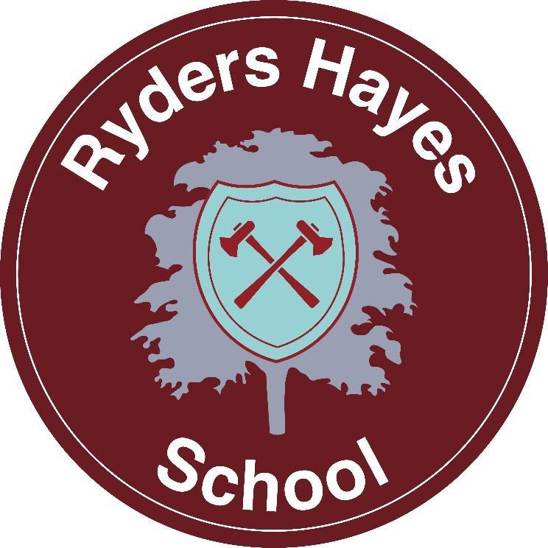

English Guidance 2026-27

Ryders Hayes School Gilpin Crescent Pelsall
Walsall
WS3 4HX Bridie White
01922 683008 English Leader
postbox@ryders-hayes.co.uk September 2026
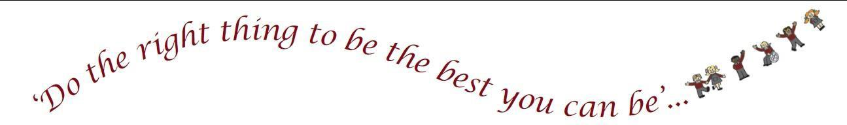

Contents
- Visions and Values 3
- Legislation and guidance 4
- Drivers
- Implementation 5
- Impact 8
- Reading for pleasure 9
- Roles and Responsibilities 9

Visions and Values

  - To empower every child to become a confident, articulate communicator and an avid, lifelong reader and writer—equipping them with the voice to share their ideas, the empathy to understand others, and the literacy skills to unlock future possibilities.

  - Ryders Hayes’ school curriculum links all learning and experiences for its pupils. The national curriculum forms one part of the school curriculum. It is an inspiring, character-building curriculum for Ryders Hayes’ pupils, using cross-curricular key experiences to deliver national curriculum content.

  - The curriculum is designed to build a schema by developing knowledge + vocabulary through a range of key experiences and deliberate practice.

“Talk is the most powerful tool of communication in the classroom and it’s fundamentally central to the acts of teaching and learning.” Professor Frank Hardman
  - We believe every pupil is a potential communicator, reader, and writer. Our curriculum is designed to enable each pupil to:
EXPLORE: by creating awe and wonder about the world around them and beyond, through texts and visual stimuli.

DEVELOP: by providing opportunities for children to communicate their own thoughts and ideas through a variety of media.

LINK: be inspired and find out more. So that all children are:
    - Resourceful, and engaged in the literary world around them
    - Resilient when things go wrong (as they do!).
    - Reciprocal, and can communicate and develop their ideas by listening and explaining.
    - Reflective, and use their knowledge and skills to make links with other areas.
  - Immersed in high quality books and texts and grow up with a love for reading and writing; have the skills they need to succeed beyond school including into further and higher education; develop important life-skills in relation to the world in which they live; have high aspirations for their future careers.

  - At Ryders Hayes Primary School, we believe literacy is a fundamental life skill. It underpins the school curriculum by developing students’ abilities to speak, listen, read and write for a wide range of purposes, using language to learn and communicate, to think, explore and organise. All curriculum areas support students’ learning to express themselves correctly and appropriately and to read accurately and with understanding.

Legislation and guidance
  - This policy reflects the requirements for academies to provide a broad and balanced curriculum as per the Academies Act 2010.

  - It also reflects requirements for inclusion and equality as set out in the Special Educational Needs and Disability Code of Practice 2014 and Equality Act 2010, and refers to curriculum-related expectations of governing boards set out in the Department for Education’s Governance Handbook.

  - It complies with our funding agreement and articles of association.

  - In addition, this policy acknowledges the requirements for promoting the learning and development of children set out in the Early Years Foundation Stage (EYFS) statutory framework.

Drivers
    - At Ryders Hayes the curriculum has 3 drivers chosen specifically to permeate the curriculum to meet the needs of our children and their local context.

    - Our curriculum drivers for Ryders Hayes school are to: Explore/Create/ Build: possibilities, independence and resilience. Our English curriculum reflects this.
    - Through carefully chosen quality texts, we explore possibilities, raise aspirations, consider alternatives and improve social mobility. We create independence by expanding children’s vocabulary and cultural capital; we expose them to topical global issues and make them aware of their responsibility. We cultivate resilience through these texts and encourage mutual respect and tolerance. They are exposed to differences they may not have come across through real-life experiences and can better appreciate diversity.

3.5 Through careful, well planned and taught lessons we intend to raise aspirations, develop life- skills for future learning and the world of work, thus improving social mobility. Pupils are given opportunities to develop listening and thinking skills and express their ideas freely and respectfully, both orally and in written form. Through English lessons they learn the skills to articulate their thinking clearly. Our English curriculum provides challenges for pupils thus ensuring that pupils take risks in their learning, and are able to make and cope with making mistakes, using them as opportunities for learning.

Implementation

    - The English curriculum is designed to build conceptual understanding and maintain consistency across all year groups through standardised lesson slides. Carefully chosen texts and thoughtful planning give children opportunities to experience different cultures, places and times.

    - Each year group has clear milestones which children are expected to achieve. Each stage develops on from the previous one, to consolidate knowledge and skills.

    - Ryders Hayes children in Key Stage 1 follow ‘The Write Stuff’ curriculum and Key Stage 2 follow the English Mastery programme (Year 6 will use this starting September 2027 ), utilising reading fluency strengths and aligned with the 2014 National Curriculum in English.

    - The curriculum is delivered by class teachers. Children are taught in classes and learning is differentiated and personalised in order to give appropriate levels of work to each pupil, which challenges all.
    - Where appropriate these groups/individual children are supported by Teaching Assistants. The children work collaboratively and teach and support each other. Teaching their class all day also allows for making cross-curricular links and connections with skill, knowledge and understanding gained in English earlier in the day; to recall and recap upon prior learning.

    - Continuous provision, in the form of daily routines, replaces the teaching of some aspects of the curriculum and, in other cases, provides retrieval practice for previously learned content.

In the Foundation Stage, children are given opportunities to:

    - Speak, listen and represent ideas in their activities.
    - Use communication, language and literacy in every part of the curriculum.
    - Become immersed in an environment rich in print and possibilities for communication.

At Key Stage One, children learn to:

    - Develop confidence when speaking and listening.
    - Read and write with increased independence, effect and enthusiasm.

At Key Stage Two, children learn to:

    - Change the way they speak and write to suit different situations, purposes and audiences.
    - Read a wide range of texts and respond to the different layers of meaning within them.
    - Explore the structure and use of language.

Spoken Language

During Key Stage 1 pupils learn to speak confidently and listen to what others have to say. They begin to read and write independently and with enthusiasm, using language to explore and represent their own experiences and imaginary worlds. They work in small groups and as a class, joining in discussions and making relevant points. They also learn how to listen carefully to what other people are saying (tracking), so that they can remember the main points. This is built upon the Early Learning Goals, in Reception the children use language to imagine and recreate roles and experiences, becoming attentive listeners and interact with others in play.

Oracy
In line with the new Writing Framework, oracy is a primary focus within our curriculum. Spoken language and deliberate oracy structures are embedded across all subjects to enable pupils to articulate their thinking clearly, expand their vocabulary, and discuss ideas confidently.

Drama

Children participate in a range of drama activities, where they use language and actions to explore and convey situations and characters and emotions, creating and sustaining roles individually and when working with others. Children develop their drama with action and narrative to convey stories, themes, emotions, ideas and devise scripts. They explore dramatic techniques and comment upon how authors use these techniques in their writing.

Reading and Phonics
Reading opens the door to learning. A child who reads regularly will become a good reader. A good
reader will be able to read more challenging material. A child who reads challenging material is a child who will learn. The more a child learns, the more he or she will want to find out.

  - Throughout our Early Years and Key Stage 1, pupils' interest and pleasure in reading is developed as they learn to read confidently and independently. They focus on words and sentences and how they fit into whole texts. They work out the meaning of texts and say why they like them or do not like them.

  - At Ryders Hayes Primary we use the Read Write Inc (RWI) programme to get children off to a flying start with their phonics journey. RWI is a method of learning centered around letter sounds and phonics, and is used as a tool when teaching reading and spelling.

  - Using RWI, the children learn to read effortlessly so that they can put all their energy into comprehending what they read. It also allows them to spell effortlessly so that they can put all their energy into composing what they write.

When using RWI to read the children will:

    - learn that sounds are represented by written letters
    - learn 44 sounds and the corresponding letter/letter groups using simple picture prompts
    - learn how to blend sounds
    - learn to read words using Fred Talk
    - read lively stories featuring words they have learned to sound out
    - show that they comprehend the stories by answering questions.

  - During Key Stage 2 pupils read enthusiastically a range of materials and use their knowledge of words, sentences and texts to understand and respond to the meaning. They increase their ability to read challenging and lengthy texts independently. They reflect on the meaning of texts, analysing and discussing them with others.

  - Across the whole school, children are heard read regularly by trained adults in school. Reading skills are taught and practised regularly. Children are also taught to look for meaning beyond the literacy and make connections between different parts of texts. Comprehension is taught in every year group, embedding all of their learning. Reading is widely modelled by staff. Books from a variety of schemes are banded and the children choose a book to take home to consolidate their learning.

Writing

The features of standard spoken English are taught to all children and we demonstrate the differences for formal and informal uses. This transfers into grammatical constructions in both key stages which the children are taught both discretely and within writing, through a wide range of texts.
During Key Stage 1, pupils start to enjoy writing and see the value of writing. They learn to creatively communicate meaning in narrative and non-fiction texts and spell and punctuate correctly. They have a range of opportunities to write with a creative flair whilst writing pieces appropriate for the purpose and audience .

  - Throughout our school, the children study exemplary texts, grammar, sentence construction and how to plan texts. The children are taught rich composition skills using adventurous vocabulary, sequencing ideas and events, and are able to recount information in a clear structure, to a high standard, which suits the purpose and its reader. Children are then taught to draft and re-draft their
work, making substitutions; creatively developing their ideas and vocabulary with right discussions which then extends their writing into exciting texts. The children have discussions about their writing as if they were authors as well as readers. They are clear about the audience and the purpose for their writing.

  - Punctuation is also taught within this writing technique giving context to their grammar and punctuation. However, spelling, grammar and punctuation may also be taught discretely to ensure full coverage and understanding and to close gaps. Spelling is also linked to the phonics or relevant spelling rule that has been taught that week; the children are tested weekly. Ryders Hayes uses National Oak Academy to teach spelling, punctuation, grammar and handwriting.

  - Within both key stages, children develop an understanding and appreciation of non-fiction and non-literary texts such as: persuasion argument, explanation, instruction and descriptive writing. They are also taught how to write diaries, autobiographies, biographies and letters. They are taught to identify and use the most appropriate structure and vocabulary for each text type and also make links between structural and organisational features such as paragraphing, sub-headings and links in hypertext.

  - Children also learn from a range of modern fiction by significant children’s authors, as well as long-established children’s fiction, alongside exciting new texts too. They study good-quality poetry, classic poetry, play scripts, fiction from different cultures and traditions, myths, legends and traditional stories.

Handwriting and Spelling

At Ryders Hayes Primary, the children take pride in their work and from Reception children are taught how to write by holding a pencil properly, writing from left to right across the page, forming letters in an appropriate size with finger spaces and joining each letter using cursive script. Cursive writing is introduced from Nursery and once children can form letters correctly, they will be taught to join.

  - Handwriting and spelling lessons follow National Oak Academy resources, including weekly structured lessons and tests. The children also build early spelling foundations through RWI sessions, moving on to targeted spelling and handwriting interventions like 'Speed Up!' where additional support is required. Common exception words are taught and checked termly. Following Department of Education guidance, children learn sentence-level transcription, explicit morphology, etymology and dictation practise alongside formal weekly tests.

Cross-Curricular Literacy Opportunities

At Ryders Hayes teachers will seek to take advantage of opportunities to make cross-curricular links with other subjects. They will allow pupils to practise and apply the skills, knowledge and understanding acquired through English lessons to all areas of the curriculum through the use of challenging texts and reinforcement of key concepts to ensure knowledge is stored in long term memory.

Computing

Children should be actively engaged in developing their English skills through the use of ICT both in and out of the classroom. The use of iPads and chromebooks are used to enhance Literacy skills where appropriate , this can include as a means of communication (email).

Planning

At Ryders Hayes planning is based on the programmes of study from the 2014 National Curriculum in English. Teachers will prepare a weekly plan to define what is taught, ensuring there are clear learning challenges, appropriate to the age and ability of the children. Planning should also ensure that the needs of children within specific groups, such as those with special educational needs, more able children, EAL (English as an Additional Language) learners and other vulnerable groups, are addressed in full using a variety of means e.g. grouping, use of adults to support vulnerable children and various intervention groups with both Teacher and Teaching Assistant adopting the MITA principles.

Inclusion

Teachers set high expectations for all pupils. They will use appropriate assessment to set ambitious targets and plan challenging work for all groups, including:

    - More able pupils
    - Pupils with low prior attainment
    - Pupils from disadvantaged backgrounds
    - Pupils with SEN
    - Pupils with English as an additional language (EAL)
  - Teachers will plan lessons so that pupils with SEN and/or disabilities can study every National Curriculum subject, wherever possible, and ensure that there are no barriers to every pupil achieving and being challenged.
  - Teachers will also take account of the needs of pupils whose first language is not English. Lessons will be planned so that teaching opportunities help pupils to develop their English, and to support pupils to take part in all subjects.

  - Further information can be found in our statement of equality information and objectives, and in our SEND policy and information report.

Impact

Nothing is learned unless it rests in pupils’ long-term memories. Assessment answers two main questions: How well are pupils coping with curriculum content? And how well are they retaining previously taught content?

    - The impact is formally measured termly in the areas of reading (comprehension, fluency, phonics knowledge (where appropriate) and keywords)

    - Writing is formally assessed termly. The children also have GPS (Grammar, Punctuation and Spelling) assessments.
    - Progress and attainment is measured on a daily basis through the Assessment for Learning Profiles (ALPs) and appropriate intervention is carried out where needed.

    - The following Mastery Characteristics are assessed using the ALPs.
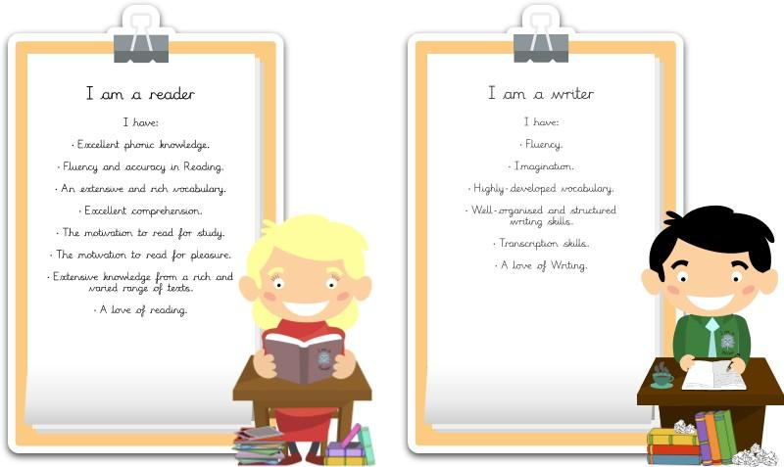

Reading for pleasure

      - We want our pupils to have a love of reading and we foster and instil this in a variety of ways
      - All pupils have access to the mobile library at least fortnightly.
      - Every classroom has a dedicated reading area with a range of reading materials.
      - Classes have regular story-time sessions and enjoy modelled reading.

      - We send out Scholastic book club leaflets half termly where the pupils can purchase books at cheaper prices
      - We run various events and competitions to promote a love of reading including poetry recitals
      - Pupils are able to loan books from our libraries to take home.
      - We celebrate World Book Day each year.

7 . Roles and responsibilities English Leader
- The English leader, Bridie White, will be responsible for ensuring consistently high standards in teaching and learning across school. She will be supported by Gemma Middleton who has expertise in KS1 and Reading.
- Monitoring the delivery and coverage of the English Curriculum.
- Monitoring and evaluating pupil progress and the quality of the Learning Environment.
- Keeping up to date with developments in English and disseminating information to colleagues as appropriate.
- Monitoring and assessing Staff PLD needs
- Purchasing and organising resources.
- Promoting a love of reading and writing, including overseeing 'Curriculum Champions' project roles (such as 'Master Storyteller', 'Chief Orator', or 'Lead Playwright') to boost pupil engagement, attendance, and peer collaboration.
- Reporting to the Curriculum Governors.
- Reporting and feeding back to staff.
- Monitoring and evaluating new initiatives.
- Evaluating and responding to whole school data.

8. Head Teacher and Governing Body

The Head Teacher and Governors will determine, support, monitor and review the school policies. They will support the use of appropriate teaching strategies by allocating resources effectively. They ensure that the building and equipment are safe. They monitor pupil attainment across the school and ensure that staff development and performance management promote good quality teaching.

Policy Review

This policy will be reviewed in full by the Governing Body.

The policy was last reviewed and agreed by the Governing Body on ……………………

It is due for review on ……………………………..
Signature ………………………………….
Date ……………………
Head Teacher

Signature ………………….……………….
Date ….…………………

