Ryders Hayes School

A Primary Learning Academy

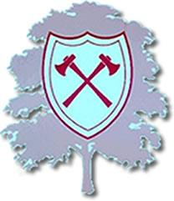

RSHE Policy

Ryders Hayes School
Gilpin Crescent
Pelsall
Walsall
WS3 4HX Kath Bowyer
01922 683008 RSHE Leader
postbox@ryders-hayes.co.uk September 2020

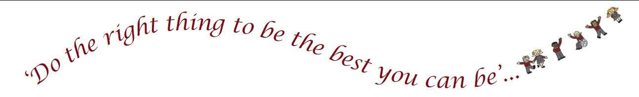
- INTRODUCTION

1.1 The School seeks to promote behaviour based on mutual respect between all members of the School community. Ryders Hayes aims to:
nurture and facilitate the growth of our pupils and their learning; equipping them with the skills and attributes to embrace the challenges of a rapidly changing world. To enjoy success for today and be prepared for tomorrow, by instilling the values of: enquiry; adaptability; resilience; morality; effective communication; thoughtfulness; collaboration; respect; international /open mindedness and a growth mind-set.

1.2 This policy outlines the learning, teaching, organisation and management of RSHE at Ryders Hayes School.

1.3 The implementation of this policy is the responsibility of all teaching staff. The responsibility for monitoring and review rests with the RSHE lead – Kath Bowyer
1.4 The curriculum is designed to build a schema by developing knowledge and vocabulary through a range of topics and deliberate practice.
2. Our Intent

2.1 Ryders Hayes Curriculum Model
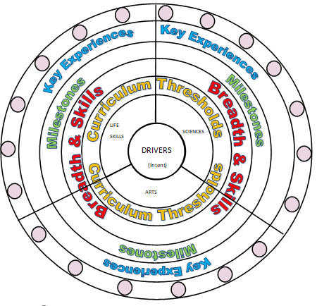

2.2 At Ryders Hayes each subject holds threshold concepts; the key disciplinary mastery aspects of each subject. They are chosen to build conceptual understanding within subjects and are repeated many times in a variety of experiences.
2.3 The threshold concepts in RSHE are:
- Relationships
- Health
- How my body changes
2.4 The threshold concepts are divided into three milestones. We expect pupils in year 1 of the milestone to develop a secure understanding of the concepts and a deeper understanding in year 2 of the milestone. Phase one (Yr1, Yr3, Yr5) in a Milestone is the knowledge building phase that provides the fundamental foundations for later application. Learning at this stage must not be rushed and will involve a high degree of repetition so that knowledge enters pupils’ long-term memory. If all the core knowledge is acquired quickly, teachers create extended knowledge.

Milestone 1 At this age children are interested in the differences between boys and girls, naming body parts, where babies come from, and friends and family. What areas of the body are private and should not be touched and who they can talk to if they are worried are also important.
Milestone 2 At this age children are interested in the emotional and physical changes of growing up, similarities and differences between each other and between boys and girls also coping with strong emotions. How to look after our bodies and how to be safe and healthy are also important.
Milestone 3 At this age children are interested in knowing about love and the different kinds of families and will be more aware of different types of partnerships and relationships. They will be curious about puberty, emotional feelings and changing body image. They will want more details about conception, how babies develop and are born and why families are important for having babies. They will also want to know who they can talk to if they want help or advice and information about growing up and personal safety including online.

2.5 The curriculum at Ryders Hayes has three drivers chosen specifically to permeate the curriculum to meet the needs of our children and their local context.
2.6 The Curriculum Drivers for Ryders Hayes School are to:
- Explore possibilities
- Create independence
- Build resilience

2.7 Through our teaching of RSHE, we intend to:

Contribute to the foundations of ‘Me In My World,’ the school’s RSHE programme aims to ‘explore attitudes and values with children about relationships, emotions, self-esteem and personal safety.’ Children will develop skills in order to make positive decisions about their health related behaviour. During RSHE children will ‘develop personal and social skills and a positive attitude to growing up’.

2.8 Through RSHE we can also:

- Improve pupils' skills in English, Maths and ICT
- Develop pupils' thinking skills
- Promote pupils' awareness and understanding of gender, cultural, spiritual and moral issues
- Develop pupils as active citizens
- Promote awareness of Health related careers

2.9 Entitlement and Equal Opportunities
We are committed to providing a teaching environment conducive to learning.
All pupils are entitled to access the RSHE curriculum at a level appropriate to their needs arising
Every pupil will receive their full entitlement to RSHE regardless of their educational ability, gender, race, disability, sexual orientation, ethnicity or faith. We aim to support children in their emotional, cultural and social, as well as academic development.
Develop an awareness of other cultures and, in doing so, achieves respect, tolerance and understanding of what it means to be a positive citizen in a multi-cultural country embedding the fundamental British vales.
Relationship Sex Health Education (RSHE) will reflect the values taught in Me in My World. RSHE will be taught in the context of relationships and health at primary school as stated in Government guidance.
https://assets.publishing.service.gov.uk/government/uploads/system/uploads/attachment_data/file/908013/Relationships_Education__Relationships_and_Sex_Education__RSE__and_Health_Education.pdf
In addition RSHE will promote self-esteem and emotional health and well-being and help them form and maintain worthwhile and satisfying relationships, based on respect for themselves and for others, at home, school, work and in the community.
In teaching Relationships Education and RSE, Ryders Hayes ensure that the needs of all pupils are appropriately met, and that all pupils understand the importance of equality and respect. Schools must ensure that they comply with the relevant provisions of the Equality Act 2010, (please see The Equality Act 2010 and schools: Departmental advice), under which sexual orientation and gender reassignment are amongst the protected characteristics.
We ensure that all teaching is sensitive and age appropriate in approach and content. At the point at which schools consider it appropriate to teach their pupils about LGBT,

Any disclosures in school will be referred to the designated safe guarding lead using CPOMS and safe guarding policy will be adhered to.

2.10 Organisation o RSHE within the Curriculum
RSHE is linked to all subjects including RE and Science, Me and My World, ICT, English through the use of cross curricula Writing.
Additionally, RSHE is part of the wider MIMW , Mindfulness and Mental Health work
3. Our Implementation

3.1 We have developed and reviewed the national scheme of guidelines for RHSE as the basis for our curriculum planning. We have adapted the national scheme to the local circumstances of our school, i.e. The nature of the children. We review our long-term plan on an annual basis.
3.2 Supporting our Curriculum Drivers, we have our knowledge categories which provide the key knowledge within subjects and help us to grow our cultural capital; making links where appropriate to our children and their learning.

3.3 The Knowledge Categories for Ryders Hayes School are:

- Location
- Settlement
- Culture and pastimes
- Significant events
- Food and farming
- Number
- Self-expression
- Career related
- Beliefs
- Innovation
- Language and oracy
- Peace and war

3.4 Within each year group key concepts are taught at stages throughout the school year. These again focus on the need of the cohort. Parents will be informed at the start of each half term of their child’s key objectives, how they as parents can support at home and the government expectations by the end of Primary school.

3.5 Teaching and Learning in RSHE will be in line with the school’s Behaviours for Learning Policy, where provision is made for all learning styles and guidelines for conduct in lessons for pupils and staff.
The RSHE curriculum at Ryders Hayes School is designed to provide children with learning opportunities that reflect the breadth and balance of contexts outlined from
3.6 As an integral part of the teaching and learning of RHE children will be given the opportunity to undertake a variety of lessons to learn about themselves and others and how they change.
RSHE is a continuous process of learning, which begins well before the children enter our school and continues into adulthood. We have planned a progressive curriculum appropriate to each age group. All adults working with children have a part to play in supporting the delivery of RSHE.

3.10 Key Experiences:

Ryders Hayes RSHE curriculum is a bespoke model to cater for the needs of the children and key experiences have been carefully selected to ensure that they allow children to explore/create/ build: possibilities, resilience and independence. In line with the DFE guidance
The Key experiences include:

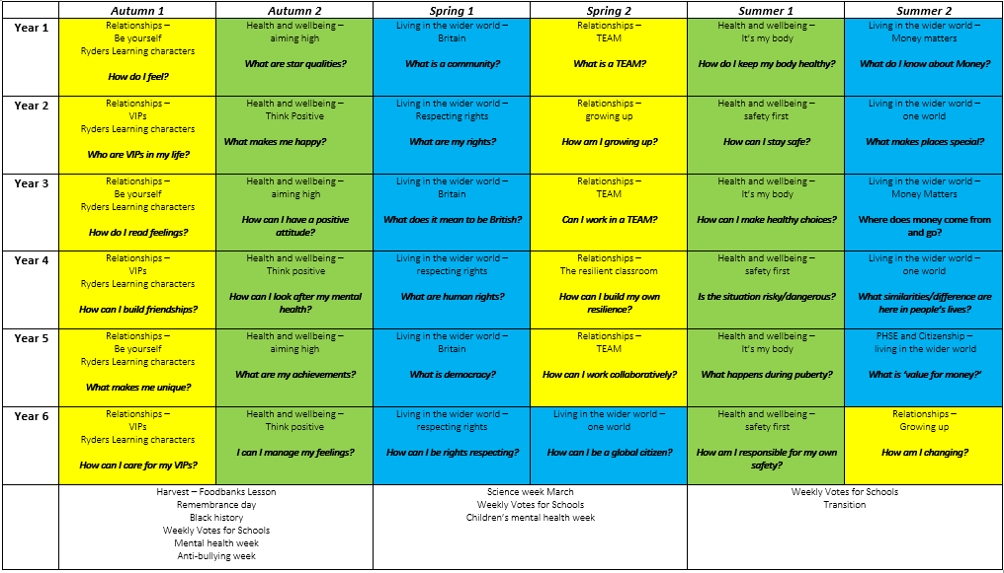

3.11 The role of the RHE Leader is to:

- Support colleagues in teaching the subject content and developing their skills in planning, teaching and assessing RSHE
- Renew, update and oversee the audit of resources needed to deliver the curriculum
- Monitor and evaluate the learning and teaching of RSHE through learning walked and book trawls
- Communicate findings, ideas and resources and have an open-door policy for suggestion and questions

4. Impact

4.1 The curriculum design and planning will lead to outstanding progress for all pupils, regardless of their starting points, over time. Learning is progressive and builds on prior knowledge and understanding and supports children in producing outcomes of the highest quality. Teaching and learning is adapted to cater for the needs of all pupils; providing support for children with special educational needs and enrichment and challenge for more- able children.

4.2 Opportunities for assessing the impact will be identified in curriculum overviews for each age group, and these will be based on an assessment of key skills and essential knowledge and understanding within RSHE

4.3Methods of assessment will vary as appropriate to the learning. A portfolio of work from Y1 to Y6 will show examples of MIMW/ RSHE work included; as well as appropriate evidence from EYFS – understanding the world and will be used to support judgments.

4.4 In RSHE the use of technology is also used to record and gain evidence of children’s knowledge and skills. Children will be set small tasks in order to demonstrate the knowledge and skills they have learnt during their learning journey and as part of end of Milestones. These tasks will be completed throughout the year to monitor and evidence progression and attainment. Pupil voice will be used to assess the progress in understanding and applying skills needed to become aware of themselves.

Resources
4.5 RSHE resources are stored in Y5 and Y6 classrooms / Science cupboard. Also to use Walsall resources Growing up (on line). The PHSE website. Other relevant resources.
4.6 If new or additional resources are required this is the responsibility of the RSHE and MIMW Leader to source as well as replenish necessary resources. The RSHE Leader is the curator of the subject and will update and provide medium term plans to each year group, whilst acting as a curator for the RHE.

Health and Safety

4.7 This policy needs to be read alongside our Health and Safety Policy. Consideration needs to be given to conducting appropriate Risk Assessments and ensuring the safeguarding of children and staff when planning and carrying out RSHE activities.
Parents will be informed prior to puberty sessions being delivered in Y5 and Y6 .Parent will be invited into school so content of lessons can be shared and explained.
Behaviour expectations will be discussed with the children at the start of puberty sessions.

Monitoring and Evaluation

4.8 The teaching and learning of RSHE will be monitored through the analysis of medium-term planning, Me in My World books, pupil voice interviews, analysis of assessment data, scrutiny of work samples, completion and recording of RSHE to assess skills and knowledge and learning walks, in line with the School Development Plan.

4.9The MIMW and RSHE leader will evaluate progress that has been made and the impact of the curriculum to ensure all pupils have been taught the knowledge for them to develop understanding about themselves and how their body changes.

4.10 The school will review this policy annually and assess its implementation and effectiveness.

